**Grafana Dashboards Details**

1. **Active Monitoring Dashboard(9001).**

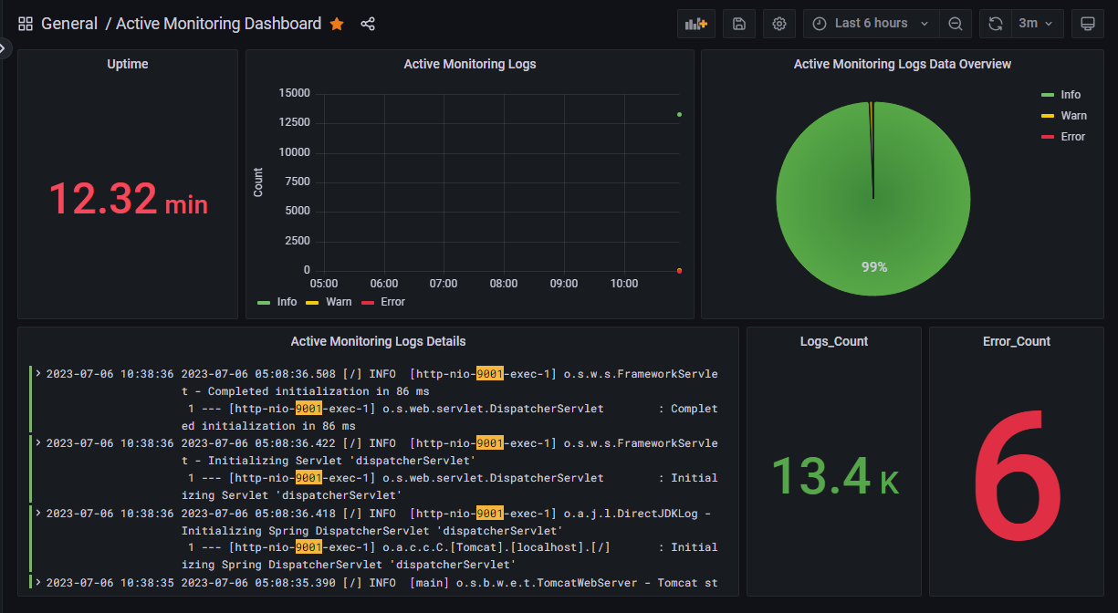

There are Six panels in this dashboard.

**Panel 1(Uptime):** In this panel Prometheus query is working which is showing service up time i.e from how much time service is up.

Query - > process_uptime_seconds {instance="threat-monitor-backend:9001”, job="activity monitoring"}

**Panel 2(Active Monitoring Logs):** In this panel Loki queries are working which is showing count of Info, Error and Warn in the logs according to the selected time range.

Query - > count_over_time({level="INFO", app="active-monitoring-service"} |= `9001` [$__range])

count_over_time({level="WARN", app="active-monitoring-service"} |= `9001` [$__range])

count_over_time({app="active-monitoring-service", level="ERROR"} |= `9001` [$__range])

**Panel 3(Active Monitoring Logs Data Overview):** In this panel Loki queries are working which is showing ratio of Info, Error and Warn coming in the logs for selected time range.

Query - > count_over_time({level="INFO", app="active-monitoring-service"} |= `9001` [$__range])

count_over_time({app="active-monitoring-service", level="WARN"} |= `9001` [$__range])

count_over_time({app="active-monitoring-service", level="ERROR"} |= `9001` [$__range])

**Panel 4(Active Monitoring Logs Details):** In this panel Loki query is working which is showing logs of the service. This panel is to show detailed logs for the service. Also, port number of the service is highlighted in the logs.

Query - > {traceID="NONE", level!="DEBUG", app="active-monitoring-service"} |= `9001`

**Panel 5(Logs_Count):** In this panel Loki query is working and is showing total count of logs for the selected time range.

Query - > sum(count_over_time({traceID="NONE", level!="DEBUG", app="active-monitoring-service"} |= `9001` [$__range]))

**Panel 6(Error_Count):** In this panel Loki query is working and is showing total count of error logs for the selected time range.

Query - > sum(count_over_time({level="ERROR", app="active-monitoring-service"} |= `9001` [$__range]))

1. **Aggregate Dashboard**

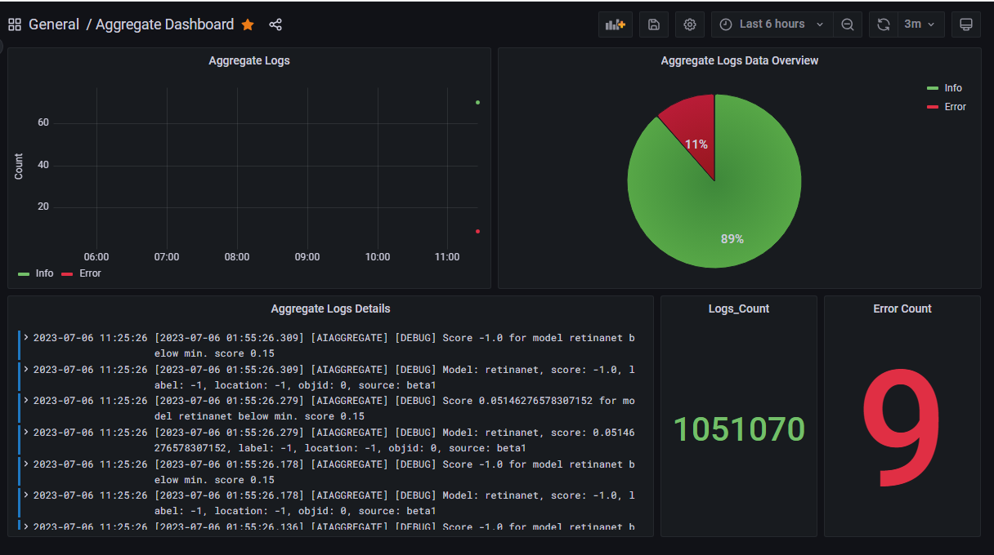

There are Five panels in this dashboard.

**Panel 1(Aggregate Logs):** In this panel Loki queries are working which is showing count of Info, Error and Warn according to time for selected time range.

Query - > count_over_time({container_name="aggregate"} |= `INFO` [$__range])

count_over_time({container_name="aggregate"} |= `WARN` [$__range])

count_over_time({container_name="aggregate"} |= `ERROR` [$__range])

**Panel 2(Aggregate Logs Data Overview):** In this panel Loki queries are working which is showing ratio of Info, Error and Warn coming in the logs for selected time range.

Query - > count_over_time({container_name="aggregate"} |= `INFO` [$__range])

count_over_time({container_name="aggregate"} |= `WARN` [$__range])

count_over_time({container_name="aggregate"} |= `ERROR` [$__range])

**Panel 3(Aggregate Logs Details):** In this panel Loki query is working which is showing logs of the service. This panel is to show detailed logs for the service.

Query - > {container_name="aggregate"}

**Panel 4(Logs_Count):** In this panel Loki query is working and is showing total count of logs for the selected time range.

Query - > sum(count_over_time({container_name="aggregate"} [$__range]))

**Panel 5(Error_Count):** In this panel Loki query is working and is showing total count of error logs for the selected time range.

Query - > sum(count_over_time({container_name="aggregate"} |= `ERROR` [$__range]))

1. **Auth Service Dashboard(9002)**

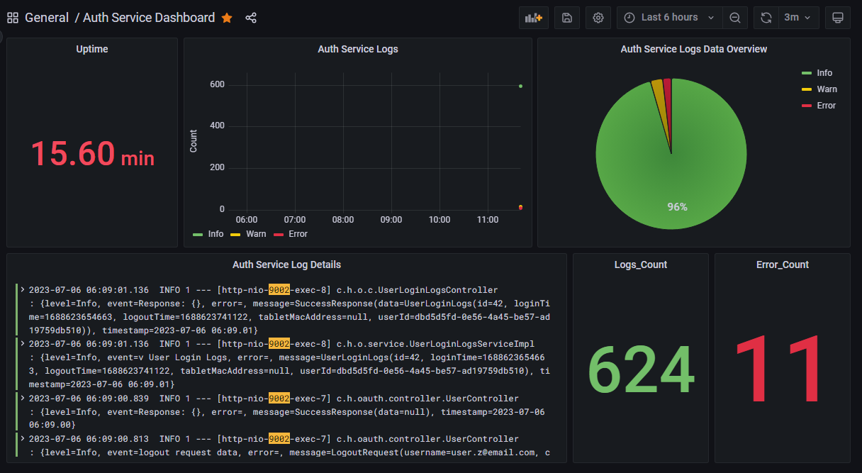

There are Six panels in this dashboard.

**Panel 1(Uptime):** In this panel Prometheus query is working which is showing service up time i.e from how much time service is up.

Query - > process_uptime_seconds{instance="auth-service:9002",job="hexwave-oauth-service"}

**Panel 2(Auth Service Logs):** In this panel Loki queries are working which is showing count of Info, Error and Warn according to selected time range.

Query - > count_over_time({app="auth-service", level="INFO"} |= `9002` [$__range])

count_over_time({app="auth-service", level="WARN"} |= `9002` [$__range])

count_over_time({app=" auth-service", level="ERROR"} |= `9002` [$__range])

**Panel 3(Auth Service Logs Data Overview):** In this panel Loki queries are working which is showing ratio of Info, Error and Warn coming in the logs for selected time range.

Query - > count_over_time({level="INFO", app=" auth-service "} |= `9002` [$__range])

count_over_time({app=" auth-service ", level="WARN"} |= `9002` [$__range])

count_over_time({app=" auth-service ", level="ERROR"} |= `9002` [$__range])

**Panel 4(Auth Service Logs Details):** In this panel Loki query is working which is showing logs of the service. This panel is to show detailed logs for the service. Also, port number of the service is highlighted in the logs.

Query - > {traceID="NONE", level!="DEBUG", app=" auth-service "} |= `9002`

**Panel 5(Logs_Count):** In this panel Loki query is working and is showing total count of logs for the selected time range.

Query - > sum(count_over_time({traceID="NONE", level!="DEBUG", app=" auth-service "} |= `9002` [$__range]))

**Panel 6(Error_Count):** In this panel Loki query is working and is showing total count of error logs for the selected time range.

Query - > sum(count_over_time({level="ERROR", app=" auth-service "} |= `9002` [$__range]))

1. **Camera Dashboard**

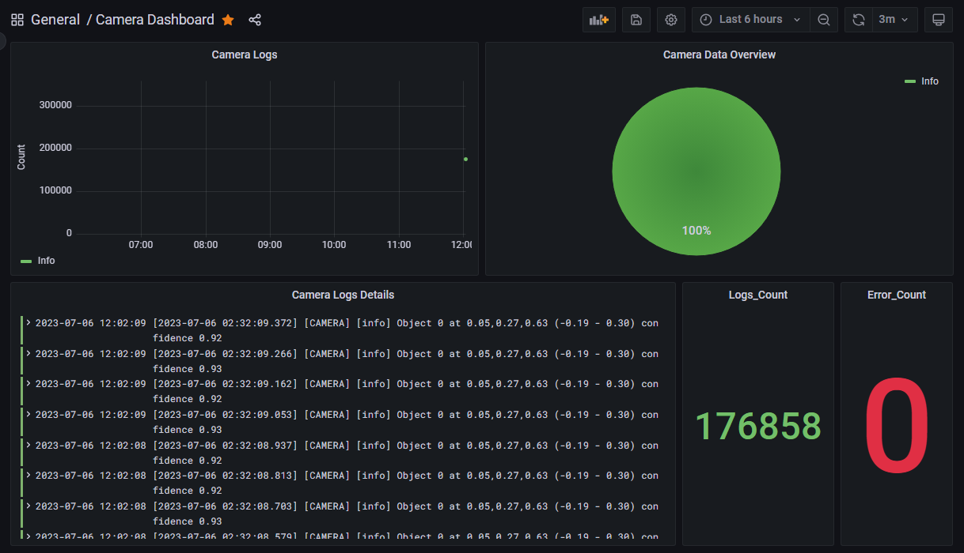

There are Five panels in this dashboard.

**Panel 1(Camera Logs):** In this panel Loki queries are working which is showing count of Info, Error and Warn according to time for selected time range.

Query - > count_over_time({container_name="camera"} |= `info` [$__range])

count_over_time({container_name="camera"} |= `error` [$__range])

count_over_time({container_name="camera"} |= `warning` [$__range])

**Panel 2(Camera Data Overview):** In this panel Loki queries are working which is showing ratio of Info, Error and Warn coming in the logs for selected time range.

Query - > count_over_time({container_name="camera"} |= `info` [$__range])

count_over_time({container_name="camera"} |= `error` [$__range])

count_over_time({container_name="camera"} |= `warning` [$__range])

**Panel 3(Camera Logs Details):** In this panel Loki query is working which is showing logs of the service. This panel is to show detailed logs for the service.

Query - > {container_name="camera"}

**Panel 4(Logs_Count):** In this panel Loki query is working and is showing total count of logs for the selected

time range.

Query - > sum(count_over_time({container_name="camera"} [$__range]))

**Panel 5(Error_Count):** In this panel Loki query is working and is showing total count of error logs for the selected time range.

Query - > sum(count_over_time({container_name="camera"} |= ` error ` [$__range]))

1. **Capture Dashboard**

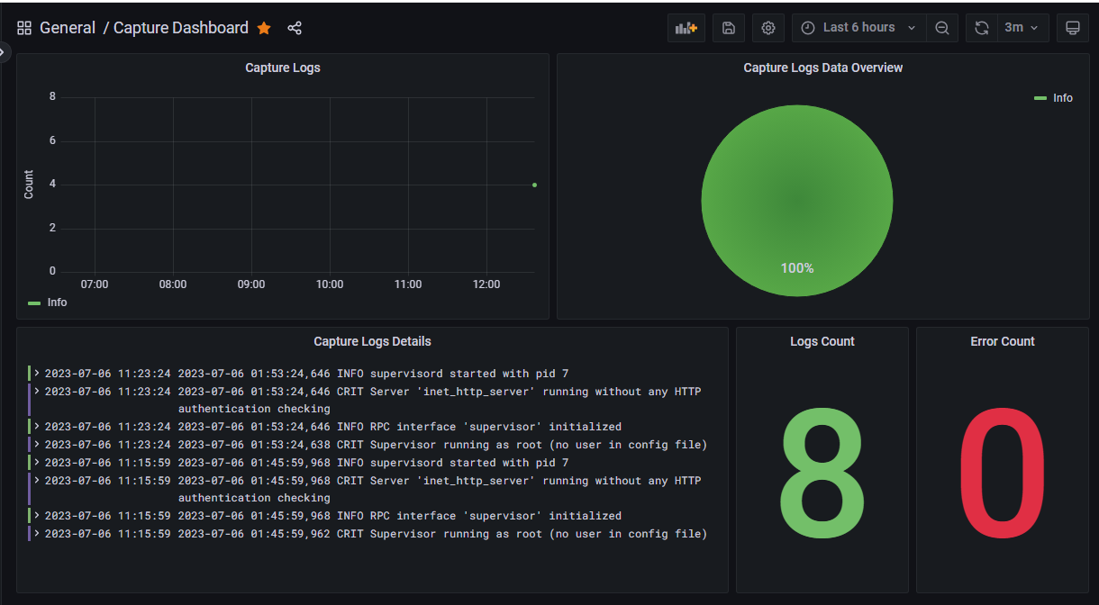

There are Five panels in this dashboard.

**Panel 1(Capture Logs):** In this panel Loki queries are working which is showing count of Info, Error and Warn according to selected time range.

Query - > count_over_time({container_name="capture"} |= `INFO` [$__range])

count_over_time({container_name="capture"} |= `ERROR` [$__range])

**Panel 2(Capture Logs Data Overview):** In this panel Loki queries are working which is showing ratio of Info and Error coming in the logs for selected time range.

Query - > count_over_time({container_name="capture"} |= `INFO` [$__range])

count_over_time({container_name="capture"} |= `ERROR` [$__range])

**Panel 3(Capture Logs Details):** In this panel Loki query is working which is showing logs of the service. This panel is to show detailed logs for the service.

Query - > {container_name="capture"}

**Panel 4(Logs Count):** In this panel Loki query is working and is showing total count of logs for the selected

time range.

Query - > sum(count_over_time({container_name="capture"} [$__range]))

**Panel 5(Error Count):** In this panel Loki query is working and is showing total count of error logs for the selected time range.

Query - > sum(count_over_time({container_name=" capture "} |= ` ERROR ` [$__range]))

1. **Core Dashboard(8123)**

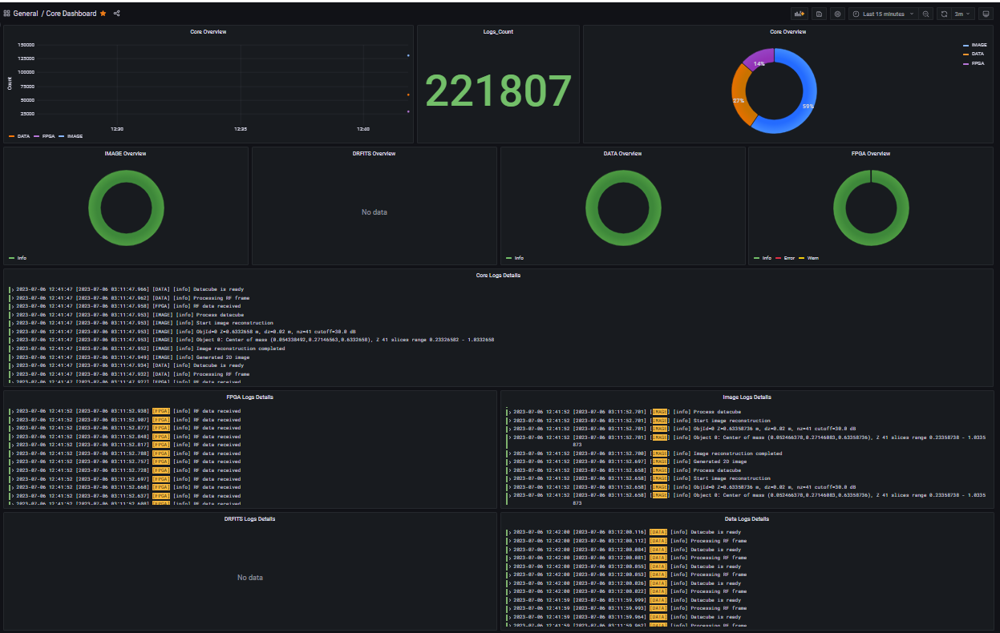

There are Twelve panels in this dashboard.

**Panel 1(Core Overview):** In this panel Loki queries are working which is showing count of DATA, FPGA, IMAGE and DRFITS according to selected time range.

Query - > count_over_time({container_name="core"} |= `[DATA]` [$__range])

count_over_time({container_name="core"} |= `[DRFITS]` [$__range])

count_over_time({container_name="core"} |= `[FPGA]` [$__range])

count_over_time({container_name="core"} |= `[IMAGE]` [$__range])

**Panel 2(Logs_Count):** In this panel Loki query is working and is showing total count of logs of service for the selected time range.

Query - > sum(count_over_time({container_name="core"} [$__range]))

**Panel 3(Core Overview):** In this panel Loki queries are working which is showing ratio of DATA, FPGA, IMAGE and DRFITS coming in the logs for selected time range.

Query - > sum(count_over_time({container_name="core"} |= `DATA` [$__range]))

sum(count_over_time({container_name="core"} |= `[DRFITS]` [$__range]))

sum(count_over_time({container_name="core"} |= `[FPGA]` [$__range]))

sum(count_over_time({container_name="core"} |= `[IMAGE]` [$__range]))

**Panel 4(IMAGE Overview):** In this panel Loki queries are working which is showing ratio of Info, Warn and Error coming in the IMAGE logs for selected time range.

Query - > sum(count_over_time({container_name="core"} |= `[IMAGE] [info]` [$__range]))

sum(count_over_time({container_name="core"} |= `[IMAGE] [warning]` [$__range]))

sum(count_over_time({container_name="core"} |= `[IMAGE] [error]` [$__range]))

**Panel 5(DRFITS Overview):** In this panel Loki queries are working which is showing ratio of Info, Warn and Error coming in the DRFITS logs for selected time range.

Query - > sum(count_over_time({container_name="core"} |= `[DRFITS] [info]` [$__range]))

sum(count_over_time({container_name="core"} |= `[DRFITS] [warning]` [$__range]))

sum(count_over_time({container_name="core"} |= `[DRFITS] [error]` [$__range]))

**Panel 6(DATA Overview):** In this panel Loki queries are working which is showing ratio of Info, Warn and Error coming in the DATA logs for selected time range.

Query - > sum(count_over_time({container_name="core"} |= `[DATA] [info]` [$__range]))

sum(count_over_time({container_name="core"} |= `[DATA] [warning]` [$__range]))

sum(count_over_time({container_name="core"} |= `[DATA] [error]` [$__range]))

**Panel 7(FPGA Overview):** In this panel Loki queries are working which is showing ratio of Info, Warn and Error coming in the FPGA logs for selected time range.

Query - > sum(count_over_time({container_name="core"} |= `[FPGA] [info]` [$__range]))

sum(count_over_time({container_name="core"} |= `[FPGA] [warning]` [$__range]))

sum(count_over_time({container_name="core"} |= `[FPGA] [error]` [$__range]))

**Panel 8(Core Los Details):** In this panel Loki query is working which is showing logs of the service as logs. This panel is to show detailed logs for the service.

Query - > {container_name="core"}

**Panel 9(FPGA Logs Details):** In this panel Loki query is working which is showing logs of the service. This panel is to show detailed logs for the FPGA in logs.

Query - > {container_name="core"} |= `[FPGA]`

**Panel 10(IMAGE Logs Details):** In this panel Loki query is working which is showing logs of the service. This panel is to show detailed logs for the IMAGE in logs.

Query - > {container_name="core"} |= `[IMAGE]`

**Panel 11(DRFITS Logs Details):** In this panel Loki query is working which is showing logs of the service. This panel is to show detailed logs for the DRFITS in logs.

Query - > {container_name="core"} |= `[DRFITS]`

**Panel 12(DATA Logs Details):** In this panel Loki query is working which is showing logs of the service. This panel is to show detailed logs for the DATA in logs.

Query - > {container_name="core"} |= `[DATA]`

1. **Device Detect Service Dashboard(9008)**

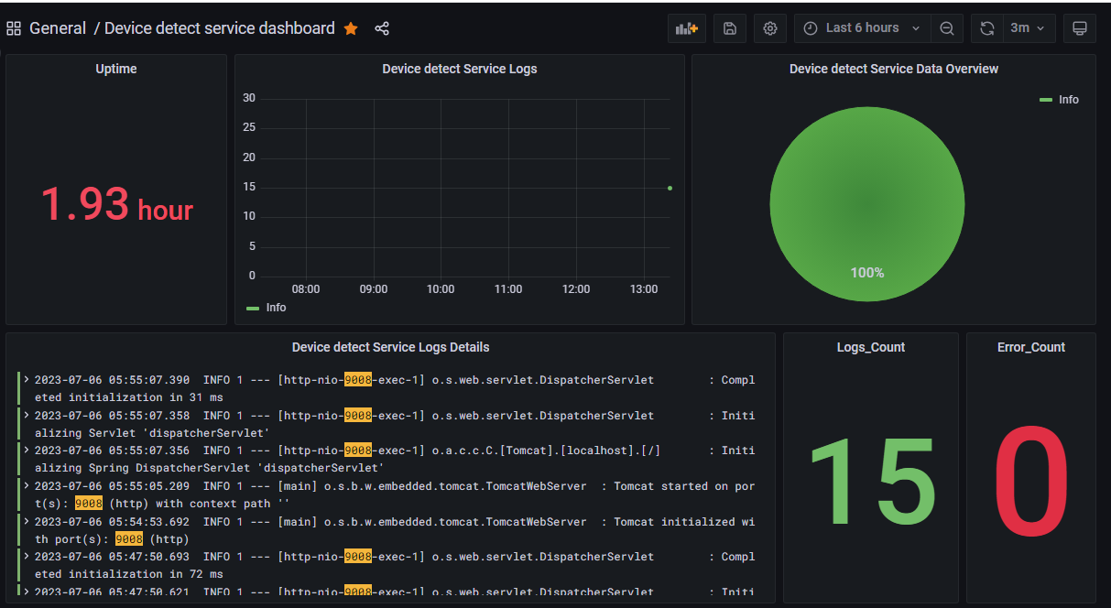

There are Six panels in this dashboard.

**Panel 1(Uptime):** In this panel Prometheus query is working which is showing service up time i.e from how much time service is up.

Query - > process_uptime_seconds{instance="device-detect-service:9008",job="device-detect-service"}

**Panel 2(Device detect Service Logs):** In this panel Loki queries are working which is showing count of Info, Error and Warn according to selected time range.

Query -> count_over_time({level="INFO", app="device-detect-service"} |= `9008` [$__range])

count_over_time({app=" device-detect-service ", level="WARN"} |= `9008` [$__range])

count_over_time({app=" device-detect-service ", level="ERROR"} |= `9008` [$__range])

**Panel 3(Device detect Service Data Overview):** In this panel Loki queries are working which is showing ratio of Info, Error and Warn coming in the logs for selected time range.

Query -> count_over_time({level="INFO", app="device-detect-service"} |= `9008` [$__range])

count_over_time({app=" device-detect-service ", level="WARN"} |= `9008` [$__range])

count_over_time({app=" device-detect-service ", level="ERROR"} |= `9008` [$__range])

**Panel 4(Device detect Service Logs Details):** In this panel Loki query is working which is showing logs of the service. This panel is to show detailed logs for the service. Also, port number of the service is highlighted in the logs.

Query - > {traceID="NONE", level!="DEBUG", app="device-detect-service"} |= `9008`

**Panel 5(Logs_Count):** In this panel Loki query is working and is showing total count of logs for the selected time range.

Query - > sum(count_over_time({traceID="NONE", level!="DEBUG", app="device-detect-service"} |= `9008` [$__range]))

**Panel 6(Error_Count):** In this panel Loki query is working and is showing total count of error logs for the selected time range.

Query - > sum(count_over_time({level="ERROR", app="device-detect-service"} |= `9008` [$__range]))

1. **Device Setting Service Dashboard(9003)**

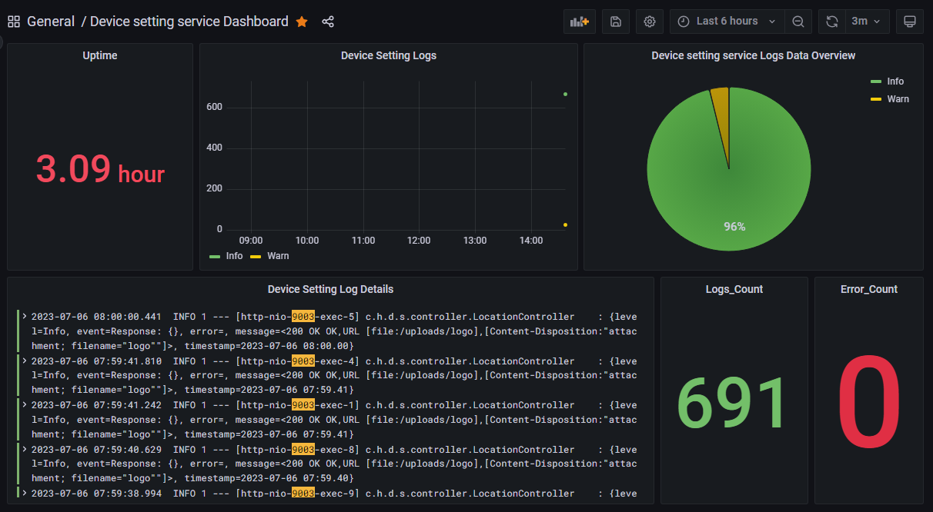

There are Six panels in this dashboard.

**Panel 1(Uptime):** In this panel Prometheus query is working which is showing service up time i.e from how much time service is up.

Query - > process_uptime_seconds{instance="device-setting-service:9003",job="hexwave-device-setting-service"}

**Panel 2(Device Settings Logs):** In this panel Loki queries are working which is showing count of Info, Error and Warn according to selected time range.

Query -> count_over_time({app="device-setting-service", level="INFO"} |= `9003` [$__range])

count_over_time({app=" device-setting-service ", level="WARN"} |= `9003` [$__range])

count_over_time({app=" device-setting-service ", level="ERROR"} |= `9003` [$__range])

**Panel 3(Device Settings service Logs Data Overview):** In this panel Loki queries are working which is showing ratio of Info, Error and Warn coming in the logs for selected time range.

Query -> count_over_time({level="INFO", app=" device-setting-service "} |= `9003` [$__range])

count_over_time({app=" device-setting-service ", level="WARN"} |= `9003` [$__range])

count_over_time({app=" device-setting-service ", level="ERROR"} |= `9003` [$__range])

**Panel 4(Device Settings Logs Details):** In this panel Loki query is working which is showing logs of the service. This panel is to show detailed logs for the service. Also, port number of the service is highlighted in the logs.

Query - > {traceID="NONE", level!="DEBUG", app=" device-setting-service "} |= `9003`

**Panel 5(Logs_Count):** In this panel Loki query is working and is showing total count of logs for the selected time range.

Query - > sum(count_over_time({traceID="NONE", level!="DEBUG", app=" device-setting-service "} |= `9003` [$__range]))

**Panel 6(Error_Count):** In this panel Loki query is working and is showing total count of error logs for the selected time range.

Query - > sum(count_over_time({level="ERROR", app=" device-setting-service "} |= `9003` [$__range]))

1. **Peripheral Service Dashboard(9012)**

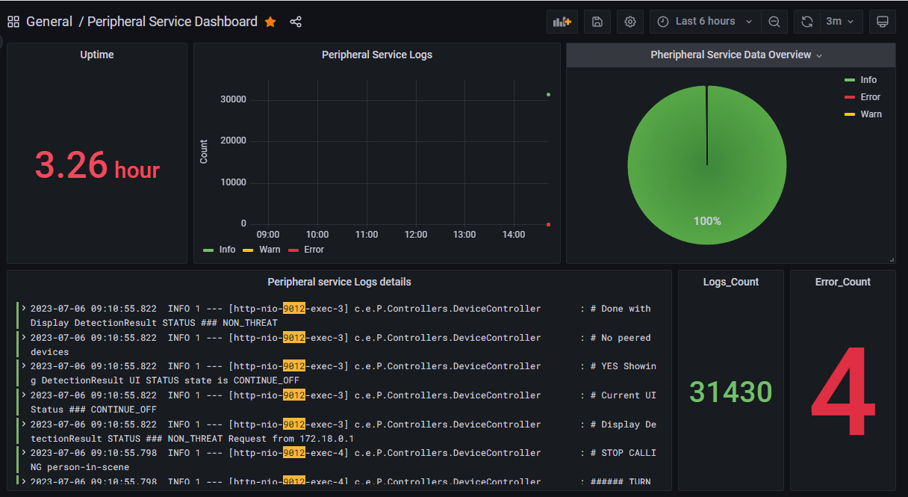

There are Six panels in this dashboard.

**Panel 1(Uptime):** In this panel Prometheus query is working which is showing service up time i.e from how much time service is up.

Query - > process_uptime_seconds{instance="peripheral-service:9012",job="peripheralserviceapi"}

**Panel 2(Peripheral Service Logs):** In this panel Loki queries are working which is showing count of Info, Error and Warn according to selected time range.

Query -> count_over_time({app="peripheral-service", level="INFO"} |= `9012` [$__range])

count_over_time({app=" peripheral -service ", level="WARN"} |= `9012` [$__range])

count_over_time({app=" peripheral -service ", level="ERROR"} |= `9012` [$__range])

**Panel 3(Peripheral Service Data Overview):** In this panel Loki queries are working which is showing ratio of Info, Error and Warn coming in the logs for selected time range.

Query -> count_over_time({level="INFO", app=" peripheral -service "} |= `9012` [$__range])

count_over_time({app=" peripheral -service ", level="WARN"} |= `9012` [$__range])

count_over_time({app=" peripheral -service ", level="ERROR"} |= `9012` [$__range])

**Panel 4(Peripheral service Logs details):** In this panel Loki query is working which is showing logs of the service as logs. This panel is to show detailed logs for the service. Also, port number of the service is highlighted in the logs.

Query - > {traceID="NONE", level!="DEBUG", app=" peripheral -service "} |= `9012`

**Panel 5(Logs_Count):** In this panel Loki query is working and is showing total count of logs for the selected time range.

Query - > sum(count_over_time({traceID="NONE", level!="DEBUG", app=" peripheral -service "} |= `9012` [$__range]))

**Panel 6(Error_Count):** In this panel Loki query is working and is showing total count of error logs for the selected time range.

Query - > sum(count_over_time({level="ERROR", app=" peripheral -service "} |= `9012` [$__range]))

1. **Recorder Dashboard**

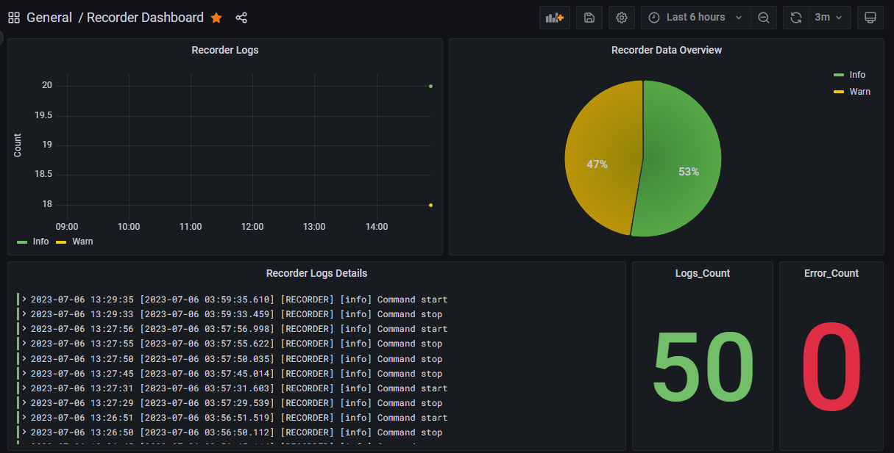

There are Five panels in this dashboard.

**Panel 1(Recorder Logs):** In this panel Loki queries are working which is showing count of Info, Error and Warn according to selected time range.

Query - > count_over_time({container_name="recorder"} |= `info` [$__range])

count_over_time({container_name="recorder"} |= `[error]` [$__range])

count_over_time({container_name="recorder"} |= `[warning]` [$__range])

**Panel 2(Recorder data Overview):** In this panel Loki queries are working which is showing ratio of Info and Error coming in the logs for selected time range.

Query - > count_over_time({container_name="recorder"} |= `info` [$__range])

count_over_time({container_name="recorder"} |= `[error]` [$__range])

count_over_time({container_name="recorder"} |= `[warning]` [$__range])

**Panel 3(Recorder Logs Details):** In this panel Loki query is working which is showing logs of the service as logs. This panel is to show detailed logs for the service.

Query - > {container_name="recorder"}

**Panel 4(Logs_Count):** In this panel Loki query is working and is showing total count of logs for the selected

time range.

Query - > sum(count_over_time({container_name="recorder"} [$__range]))

**Panel 5(Error_Count):** In this panel Loki query is working and is showing total count of error logs for the selected time range.

Query - > sum(count_over_time({container_name="recorder"} |= `[error]` [$__range]))

1. **Report Service Dashboard(9005)**

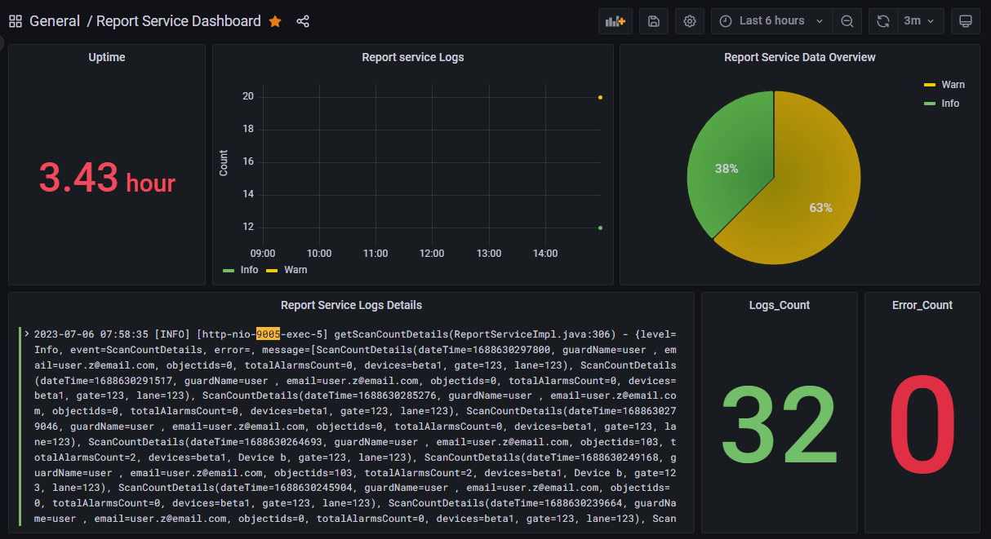

There are six panels in this dashboard.

**Panel 1(Uptime):** In this panel Prometheus query is working which is showing service up time i.e from how much time service is up.

Query - > process_uptime_seconds{instance="report-service:9005",job="hexwave-report-service"}

**Panel 2(Report Service Logs):** In this panel Loki queries are working which is showing count of Info, Error and Warn according to selected time range.

Query -> count_over_time({app="report-service", level="INFO"} |= `9005` [$__range])

count_over_time({app="report-service", level="ERROR"} |= `9005` [$__range])

count_over_time({app="report-service", level="WARN"} |= `9005` [$__range])

**Panel 3(Report Service Data Overview):** In this panel Loki queries are working which is showing ratio of Info, Error and Warn coming in the logs for selected time range.

Query -> count_over_time({app="report-service", level="INFO"} |= `9005` [$__range])

count_over_time({app="report-service", level="ERROR"} |= `9005` [$__range])

count_over_time({app="report-service", level="WARN"} |= `9005` [$__range])

**Panel 4((Report Service Logs Details):** In this panel Loki query is working which is showing logs of the service as logs. This panel is to show detailed logs for the service. Also, port number of the service is highlighted in the logs.

Query - > {traceID="NONE", level!="DEBUG", app="report-service"} |= `9005`

**Panel 5(Logs_Count):** In this panel Loki query is working and is showing total count of logs for the selected time range.

Query - > sum(count_over_time({app="report-service", level!="DEBUG"} |= `9005` [$__range]))

**Panel 6(Error_Count):** In this panel Loki query is working and is showing total count of error logs for the selected time range.

Query - > sum(count_over_time({level="ERROR", app="report-service"} |= `9005` [$__range]))

1. **Threat Monitor Process Api Dashboard(9000)**

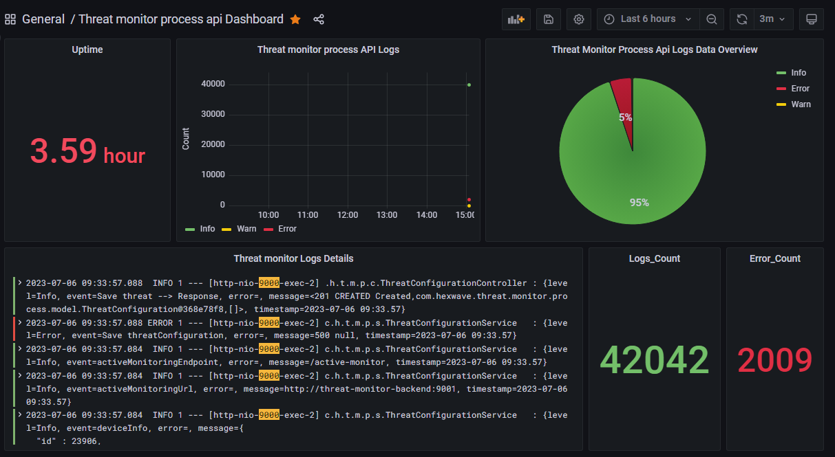

There are six panels in this dashboard.

**Panel 1(Uptime):** In this panel Prometheus query is working which is showing service up time i.e from how much time service is up.

Query - > process_uptime_seconds{instance="threat-monitor-process-api:9000",job="ml-output-simulator"}

**Panel 2(Threat monitor process API Logs):** In this panel Loki queries are working which is showing count of Info, Error and Warn according to selected time range.

Query -> count_over_time({app="threat-monitor-process-api", level="INFO"} |= `9000` [$__range])

count_over_time({app="threat-monitor-process-api", level="WARN"} |= `9000` [$__range])

count_over_time({app="threat-monitor-process-api", level="WARN"} |= `9000` [$__range])

**Panel 3(Threat monitor process API Logs Data Overview):** In this panel Loki queries are working which is showing ratio of Info, Error and Warn coming in the logs for selected time range.

Query -> count_over_time({app="threat-monitor-process-api", level="INFO"} |= `9000` [$__range])

count_over_time({app="threat-monitor-process-api", level="WARN"} |= `9000` [$__range])

count_over_time({app="threat-monitor-process-api", level="WARN"} |= `9000` [$__range])

**Panel 4((Threat monitor Logs Details):** In this panel Loki query is working which is showing logs of the service. This panel is to show detailed logs for the service. Also, port number of the service is highlighted in the logs.

Query - > {app="threat-monitor-process-api", traceID="NONE"} |= `9000`

**Panel 5(Logs_Count):** In this panel Loki query is working and is showing total count of logs for the selected time range.

Query - > sum(count_over_time({app="threat-monitor-process-api", traceID="NONE", level!="DEBUG"} |= `9000` [$__range]))

**Panel 6(Error_Count):** In this panel Loki query is working and is showing total count of error logs for the selected time range.

Query - > sum(count_over_time({app="threat-monitor-process-api", level="ERROR"} |= `9000` [$__range]))

1. **User Role Auth Service Dashboard(9007)**

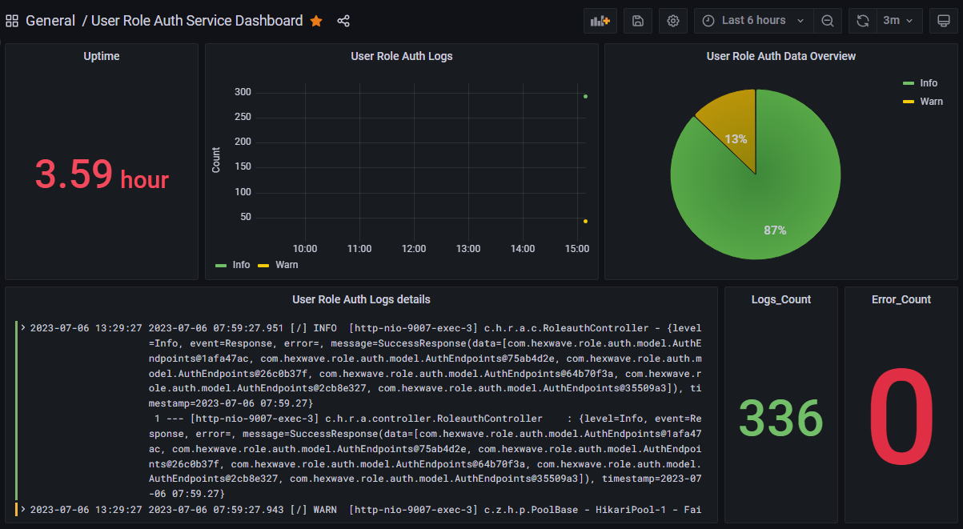

There are six panels in this dashboard.

**Panel 1(Uptime):** In this panel Prometheus query is working which is showing service up time i.e from how much time service is up.

Query - > process_uptime_seconds{instance="user-role-auth:9007",job="user-role-auth"}

**Panel 2(User Role Auth Logs):** In this panel Loki queries are working which is showing count of Info, Error and Warn according to selected time range.

Query -> count_over_time({app="user-role-auth", level="INFO"} [$__range])

count_over_time({app="user-role-auth", level="WARN"} [$__range])

count_over_time({app="user-role-auth", level="ERROR"} [$__range])

**Panel 3(User Role Auth Data Overview):** In this panel Loki queries are working which is showing ratio of Info, Error and Warn coming in the logs for selected time range.

Query -> count_over_time({app="user-role-auth", level="INFO"} [$__range])

count_over_time({app="user-role-auth", level="WARN"} [$__range])

count_over_time({app="user-role-auth", level="ERROR"} [$__range])

**Panel 4(User Role Auth Logs Details):** In this panel Loki query is working which is showing logs of the service as logs. This panel is to show detailed logs for the service.

Query - > {app="user-role-auth", level!="DEBUG"}

**Panel 5(Logs_Count):** In this panel Loki query is working and is showing total count of logs for the selected time range.

Query - > sum(count_over_time({app="user-role-auth", level!="DEBUG"} [$__range]))

**Panel 6(Error_Count):** In this panel Loki query is working and is showing total count of error logs for the selected time range.

Query - > sum(count_over_time({level="ERROR", app="user-role-auth"} [$__range]))

1. **User Setting Service Dashboard(9006)**

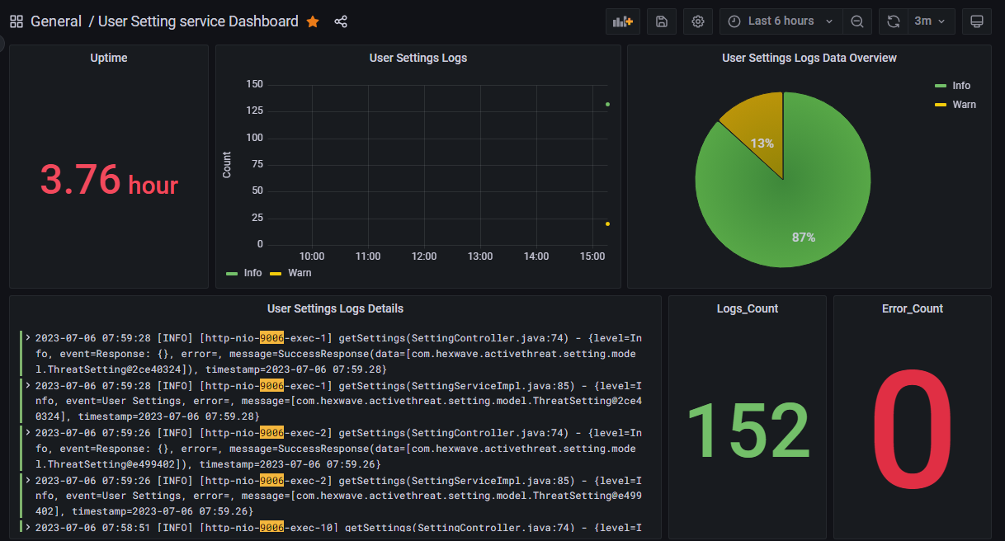

There are six panels in this dashboard.

**Panel 1(Uptime):** In this panel Prometheus query is working which is showing service up time i.e from how much time service is up.

Query - > process_uptime_seconds{instance="user-setting-service:9006",job="active-threat-user-settings"}

**Panel 2(User Settings Logs):** In this panel Loki queries are working which is showing count of Info, Error and Warn according to selected time range.

Query -> count_over_time({app="user-setting-service", level="INFO"} |= `9006` [$__range])

count_over_time({app="user-setting-service", level="WARN"} |= `9006` [$__range])

count_over_time({app="user-setting-service", level="ERROR"} |= `9006` [$__range])

**Panel 3(user Settings Logs Data Overview):** In this panel Loki queries are working which is showing ratio of Info, Error and Warn coming in the logs for selected time range.

Query -> count_over_time({app="user-setting-service", level="INFO"} |= `9006` [$__range])

count_over_time({app="user-setting-service", level="WARN"} |= `9006` [$__range])

count_over_time({app="user-setting-service", level="ERROR"} |= `9006` [$__range])

**Panel 4(User Settings Logs Details):** In this panel Loki query is working which is showing logs of the service as logs. This panel is to show detailed logs for the service. Also, port number of the service is highlighted in the logs.

Query - > {traceID="NONE", level!="DEBUG", app="user-setting-service"} |= `9006`

**Panel 5(Logs_Count):** In this panel Loki query is working and is showing total count of logs for the selected time range.

Query - > sum(count_over_time({traceID="NONE", level!="DEBUG", app="user-setting-service"} |= `9006` [$__range]))

**Panel 6(Error_Count):** In this panel Loki query is working and is showing total count of error logs for the selected time range.

Query - > sum(count_over_time({app="user-setting-service", level="ERROR"} |= `9006` [$__range]))

1. **Retinanet Dashboard**

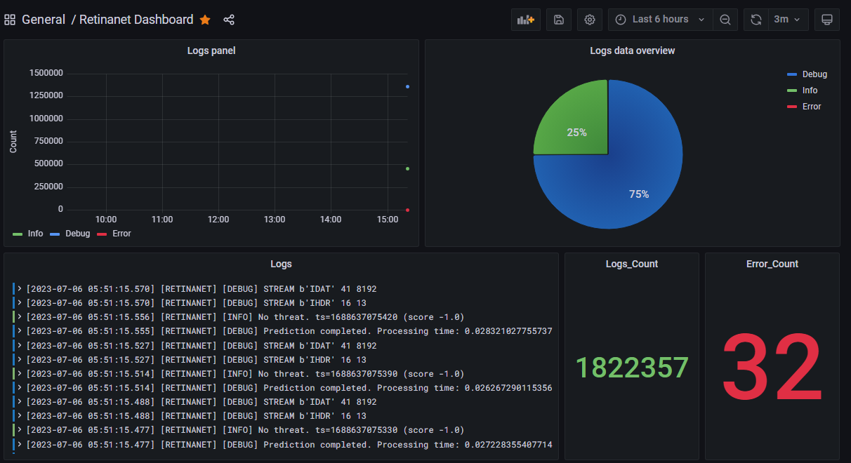

There are Five panels in this dashboard.

**Panel 1(Logs panel):** In this panel Loki queries are working which is showing count of Info, Error, Warn and Debug according to selected time range.

Query - > count_over_time({container_name="retinanet"} |= `INFO` [$__range])

count_over_time({container_name="retinanet"} |= `DEBUG` [$__range])

count_over_time({container_name="retinanet"} |= `Error` [$__range])

count_over_time({container_name="retinanet"} |= `warning` [$__range])

**Panel 2(Logs data overview):** In this panel Loki queries are working which is showing ratio of Info and Error coming in the logs for selected time range.

Query - > count_over_time({container_name="retinanet"} |= `INFO` [$__range])

count_over_time({container_name="retinanet"} |= `DEBUG` [$__range])

count_over_time({container_name="retinanet"} |= `Error` [$__range])

count_over_time({container_name="retinanet"} |= `warning` [$__range])

**Panel 3(Logs):** In this panel Loki query is working which is showing logs of the service. This panel is to show detailed logs for the service.

Query - > {container_name=" retinanet"}

**Panel 4(Logs_Count):** In this panel Loki query is working and is showing total count of logs for the selected time range.

Query - > sum(count_over_time({container_name=" retinanet"} [$__range]))

**Panel 5(Error_Count):** In this panel Loki query is working and is showing total count of error logs for the selected time range.

Query - > sum(count_over_time({container_name=" retinanet"} |= `[Error]` [$__range]))

1. **Alarm Information Dashboard**

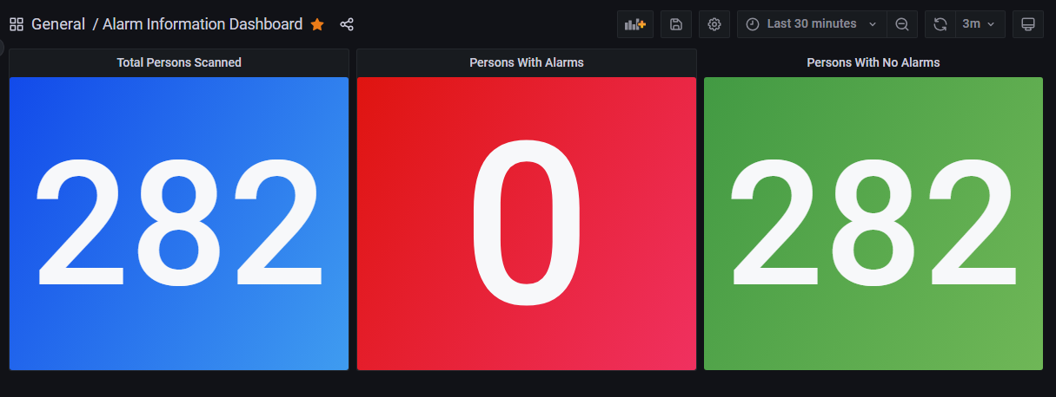

There are Three panels in this dashboard.

**Panel 1(Total Persons Scanned):** In this panel Loki query is working which is showing Total Person Scanned Count.

Query - > sum(count_over_time({app="threat-monitor-process-api"} |= ` "personIn" : false,` [$__range]))

**Panel 2(Persons with Alarms):** In this panel Loki query is working and is showing total count Persons with Alarms.

Query - > sum(count_over_time({app="threat-monitor-process-api"} |= `"objectDetected" : true,` |= ` "personIn" : false,` [$__range]))

**Panel 3(Persons With No Alarms):** In this panel Loki query is working and is showing total count persons with no alarms.

Query - > sum(count_over_time({app="threat-monitor-process-api"} |= `"objectDetected" : false,` |= ` "personIn" : false,` [$__range]))

1. **Hexwave Dashboard**

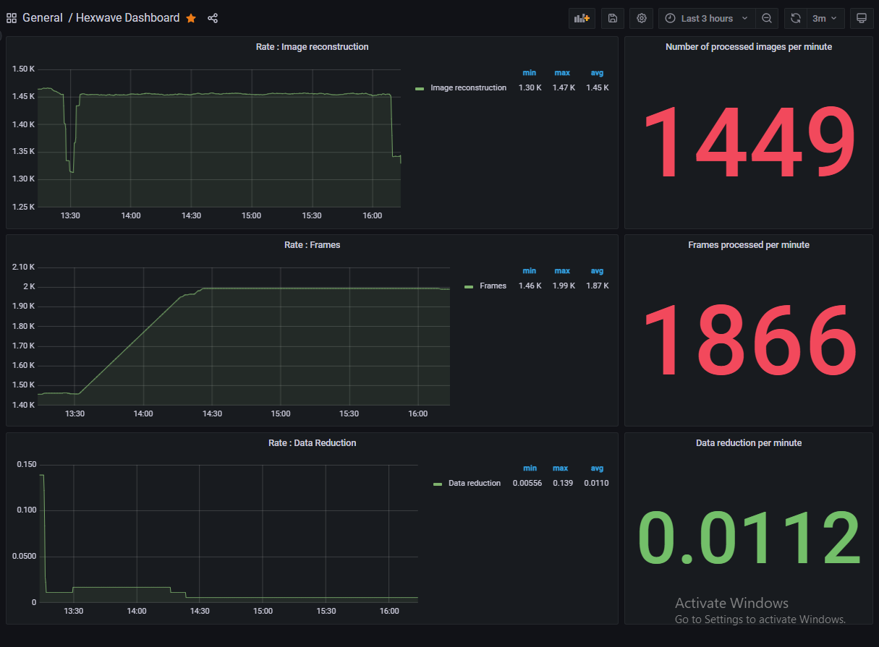

There are six panels in this dashboard.

**Panel 1(Rate: Image Reconstruction):** In this panel Loki query is working which is showing rate of Image reconstruction per minute in graphical format and also showing its minimum, maximum and average count.

Query - > rate({container_name="core"} |= `Image reconstruction completed` [5m]) * 60

**Panel 2(Number of processed images per minute):** In this panel Loki query is working which is showing count of rate of Image reconstruction per minute in number format.

Query - > rate({container_name="core"} |= `Image reconstruction completed` [5m]) * 60

**Panel 3(Rate: Frames):** In this panel Loki query is working which is showing rate of Processing RF frame per minute in graphical format and also showing its minimum, maximum and average count.

Query - > rate({container_name="core"} |= `Processing RF frame` [$__range]) * 60

**Panel 4(Frames processed per minute):** In this panel Loki query is working which is showing count of rate of Processing RF frame per minute in number format.

Query - > rate({container_name="core"} |= `Processing RF frame` [$__range]) * 60

**Panel 5(Rate: Data Reduction):** In this panel Loki query is working which is showing rate of Data reduction per minute in graphical format and also showing its minimum, maximum and average count.

Query - > rate({container_name="core"} |= `Data reduction 0.0.1` [$__range]) * 60

**Panel 6(Data Reduction per minute):** In this panel Loki query is working which is showing count of rate of Data reduction per minute in number format.

Query - > rate({container_name="core"} |= `Data reduction 0.0.1` [$__range]) * 60

1. **System Process Metrics**

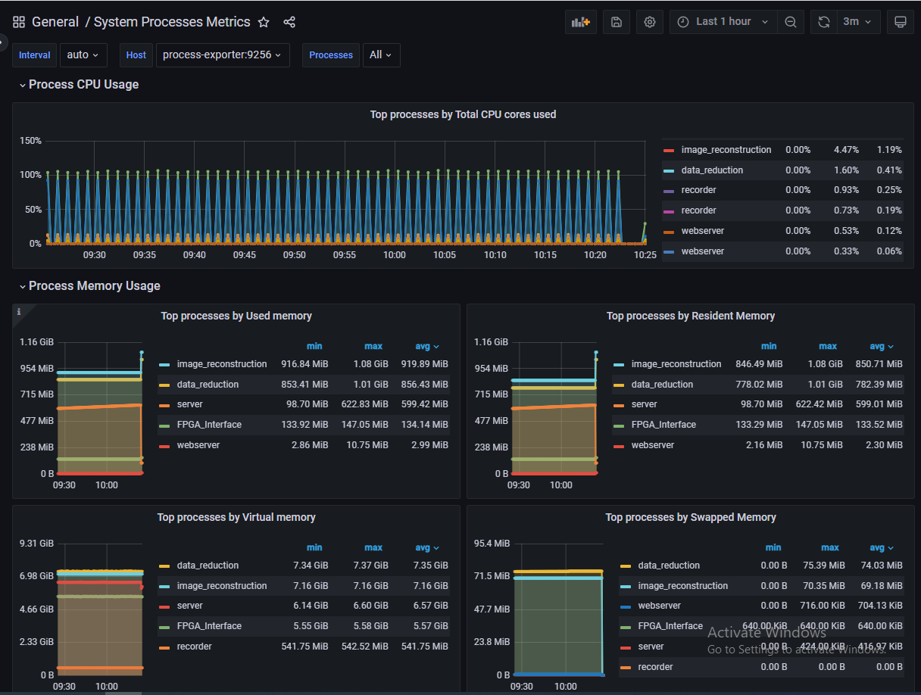 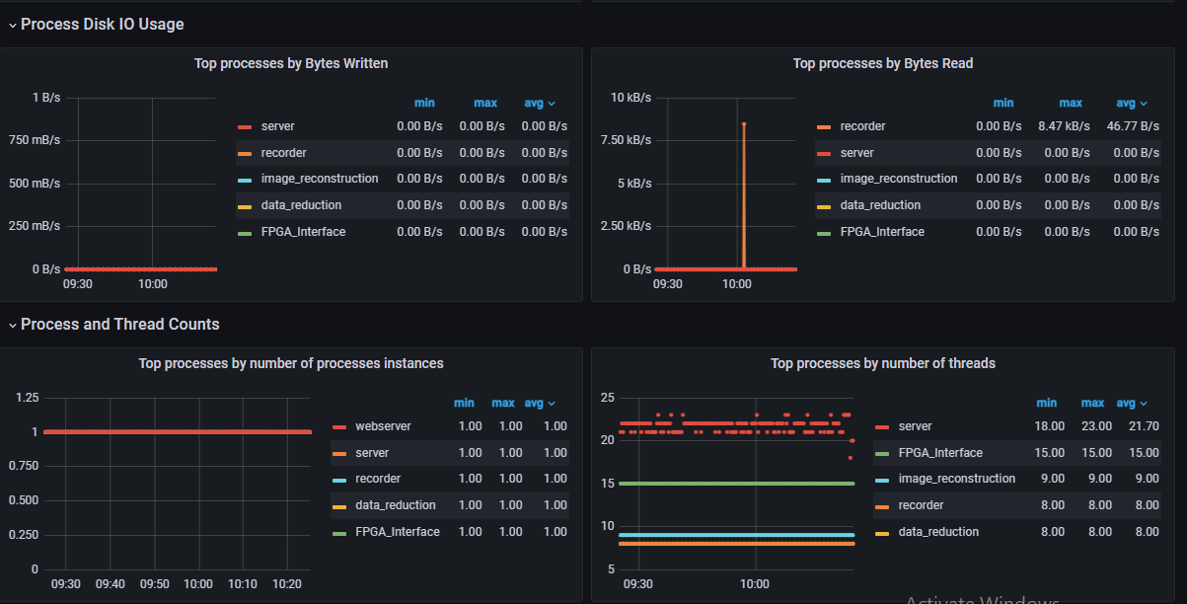 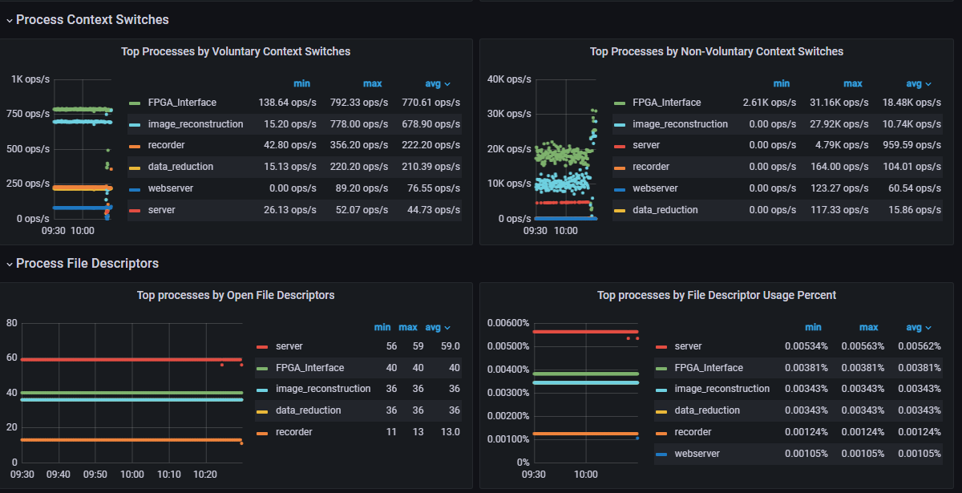 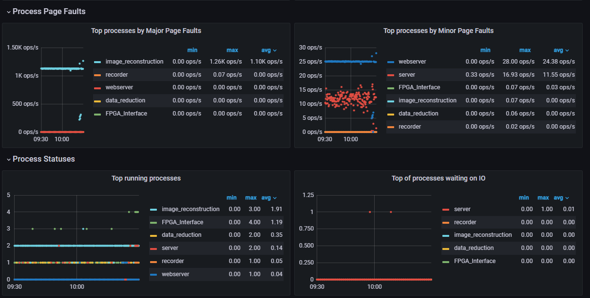

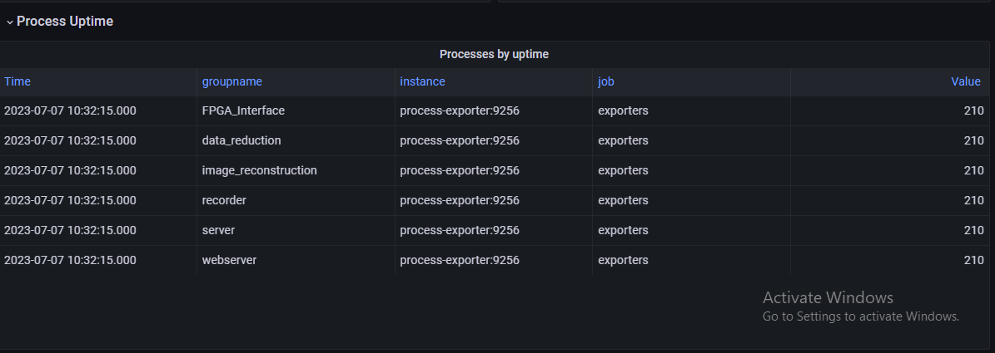

1. **Node Exporter Metrics**

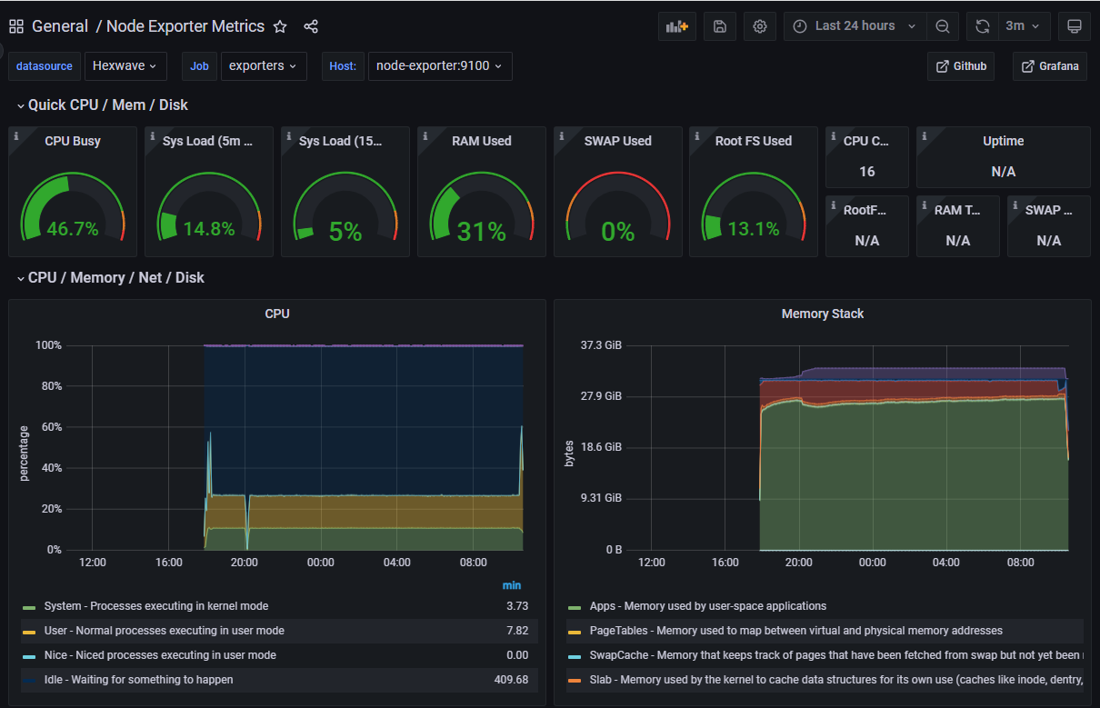 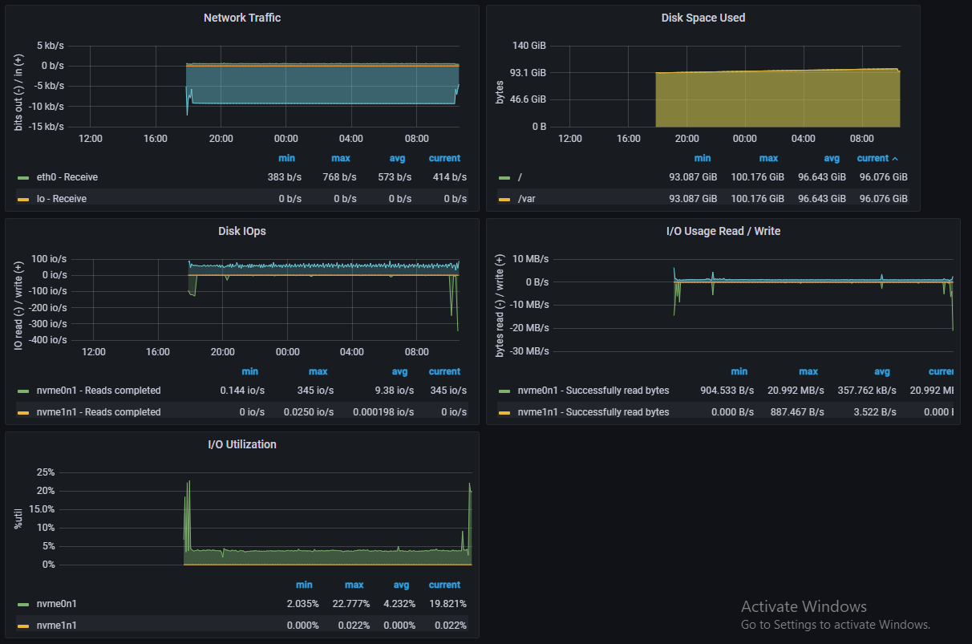 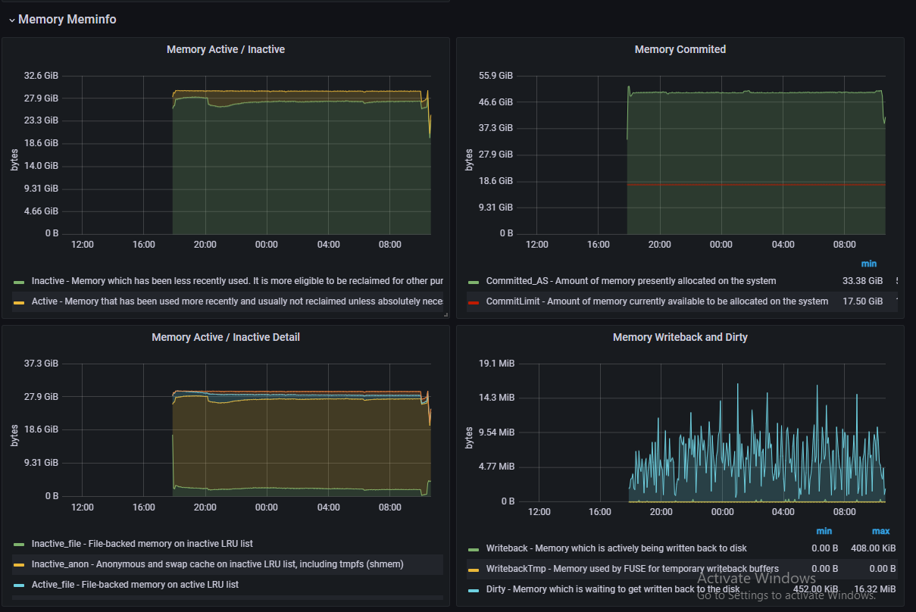 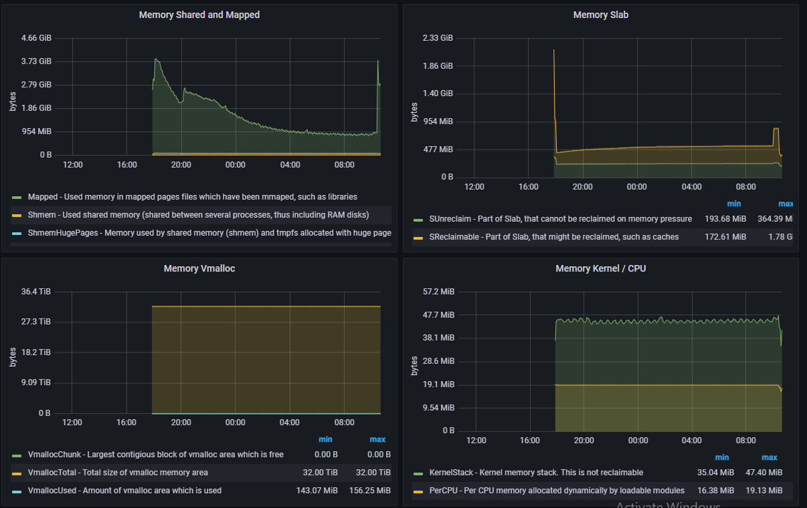 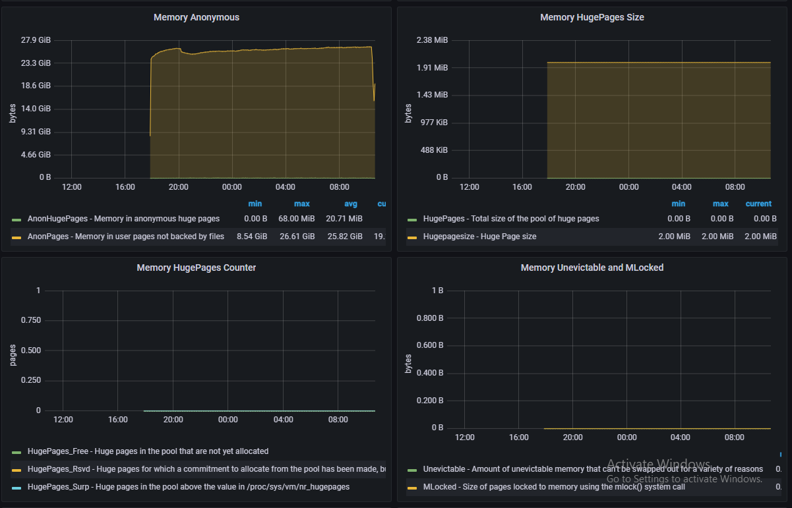 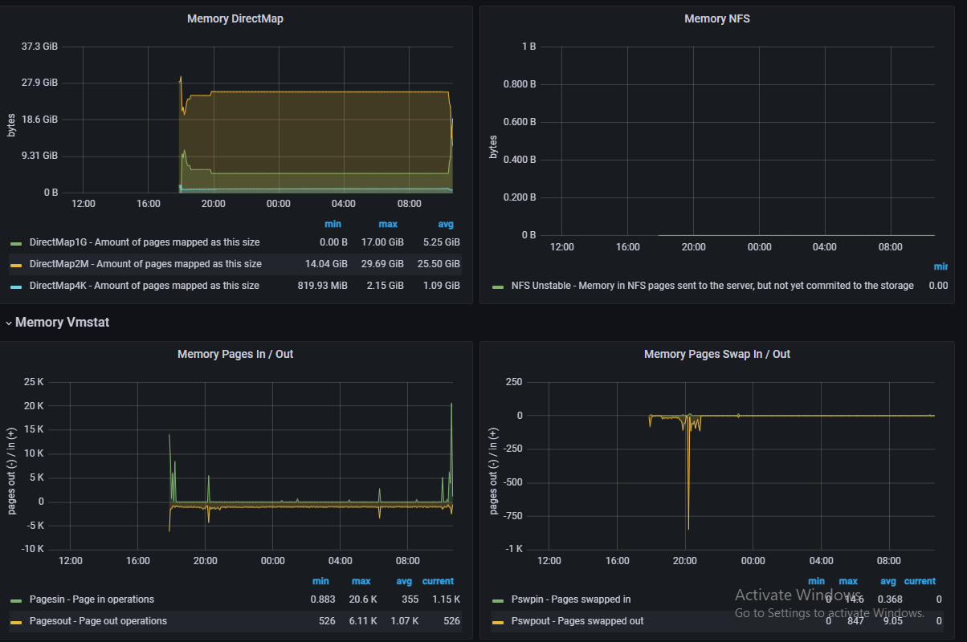

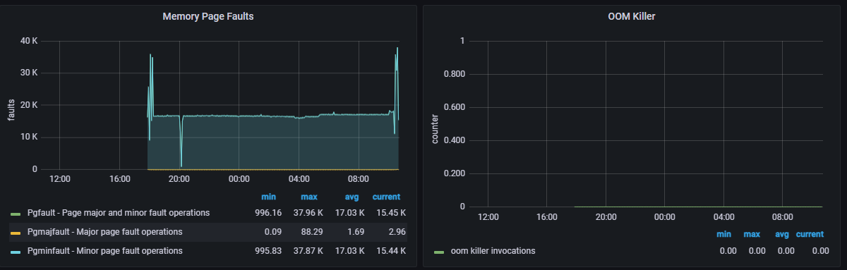

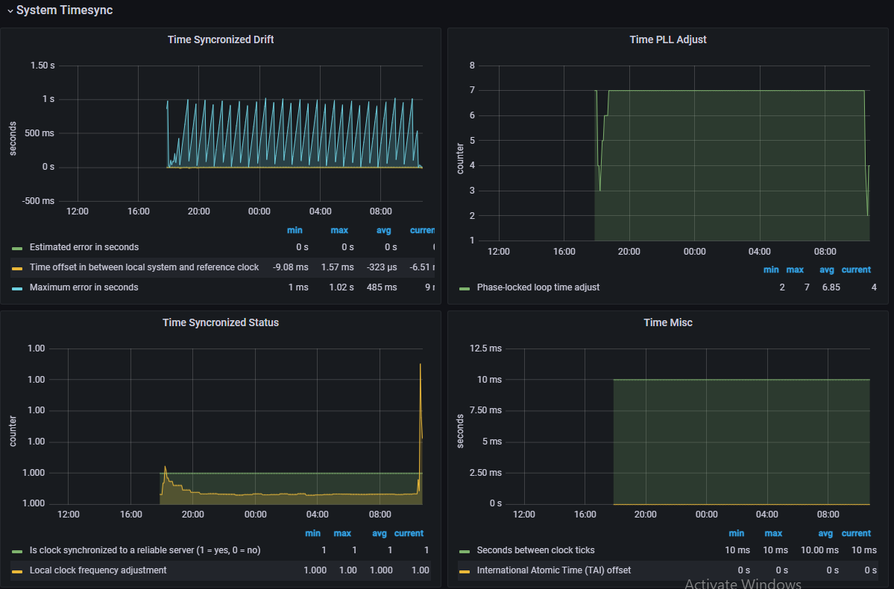 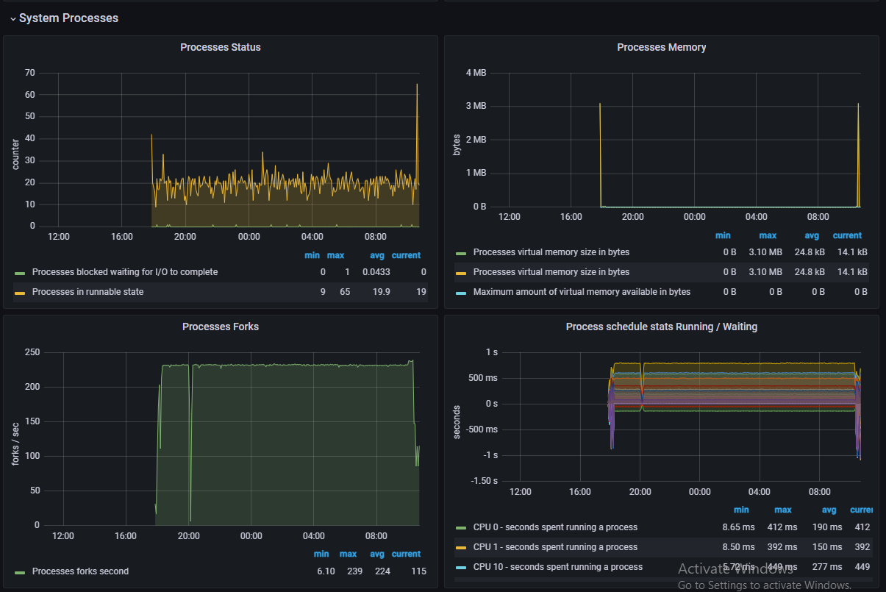 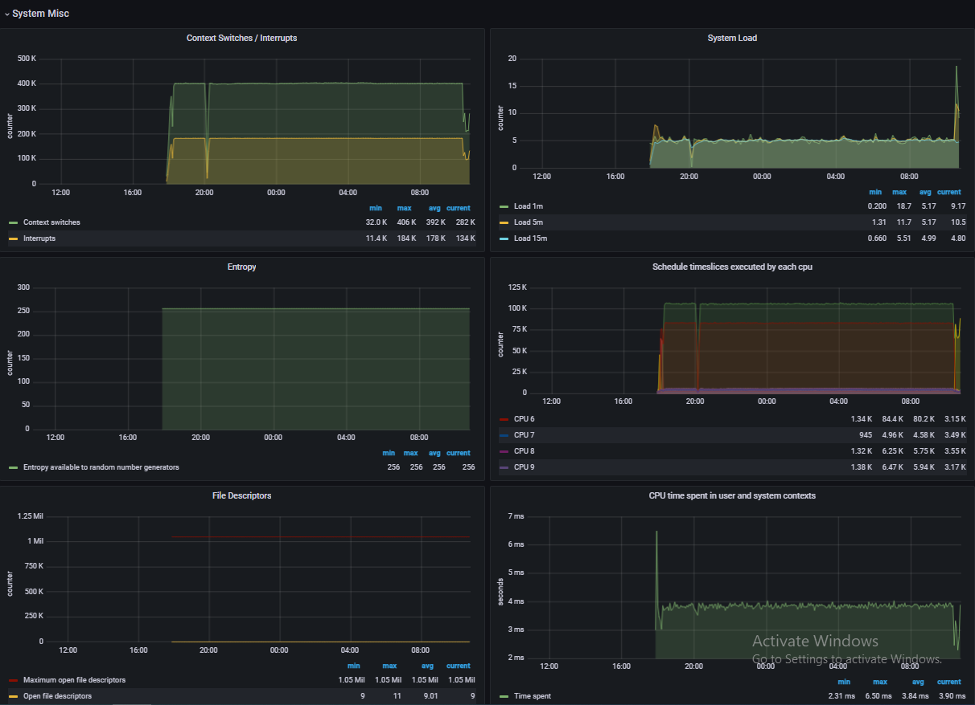 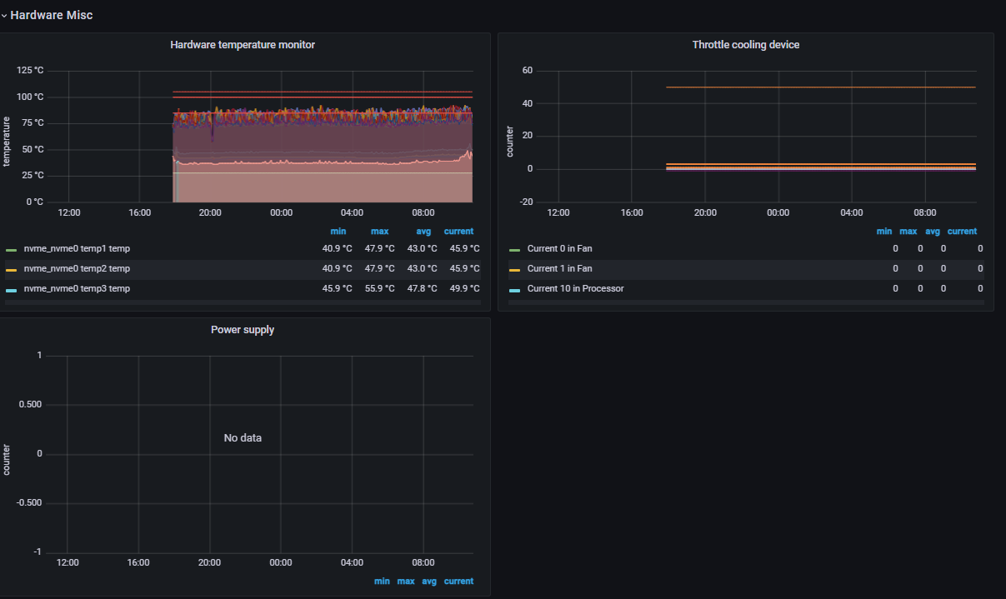 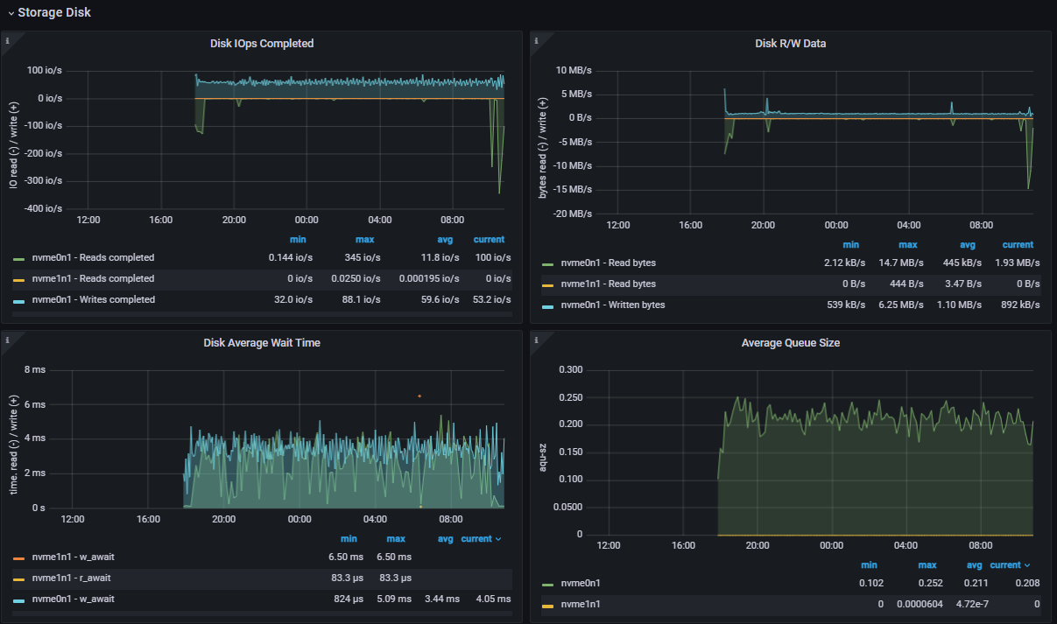 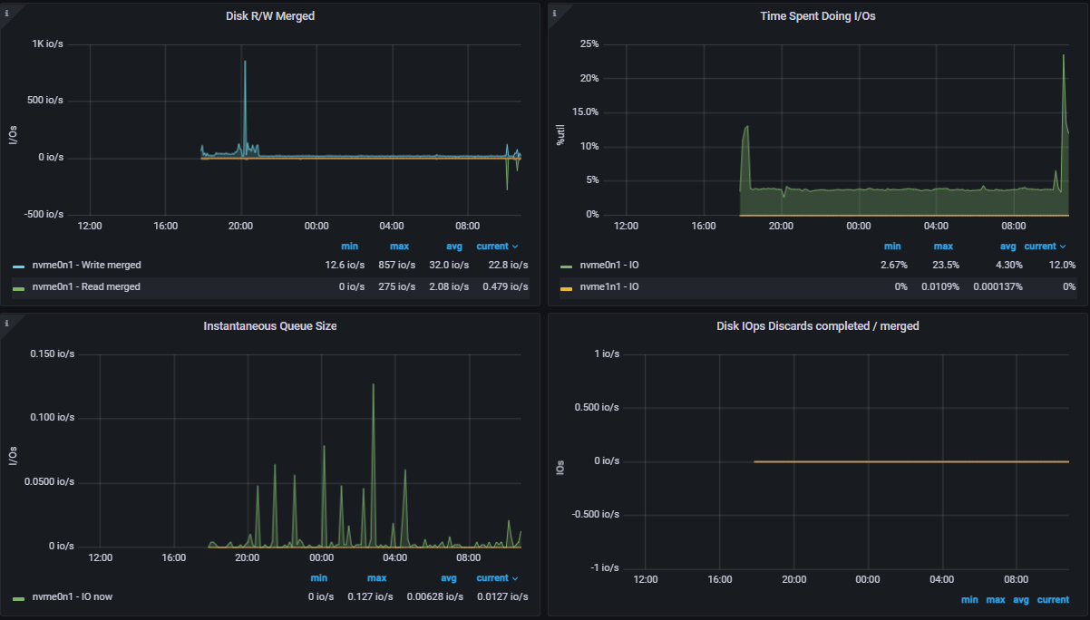 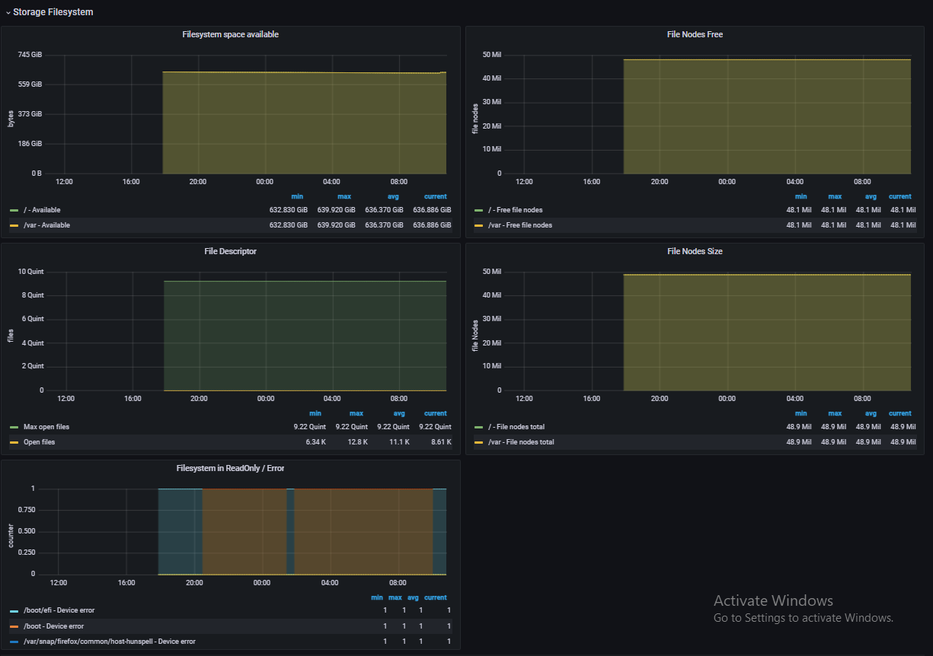 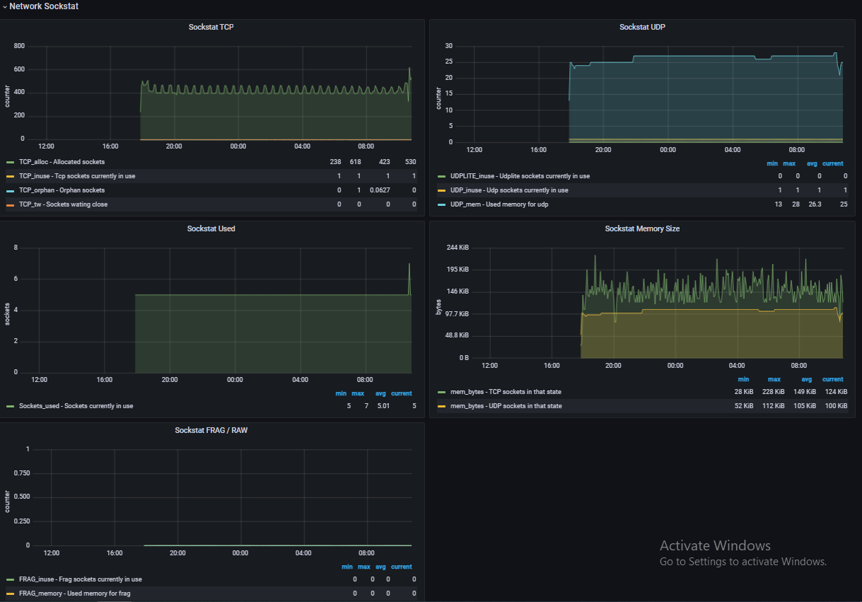 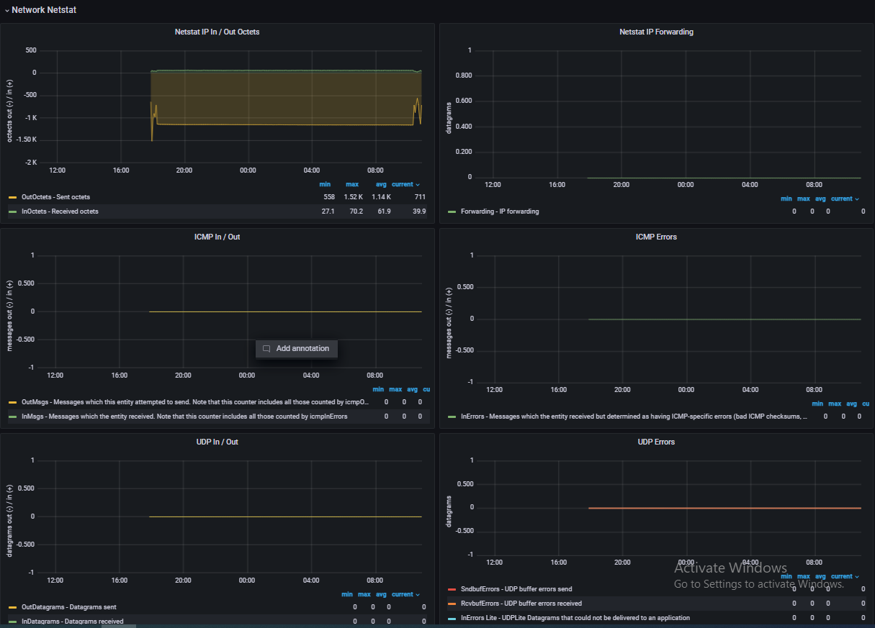 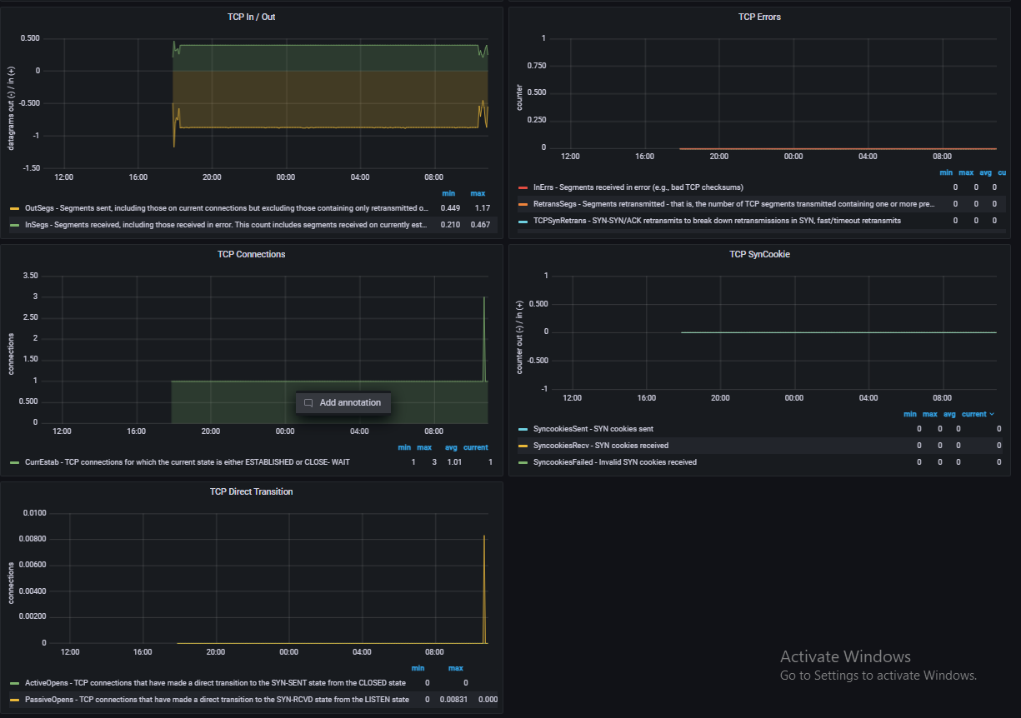 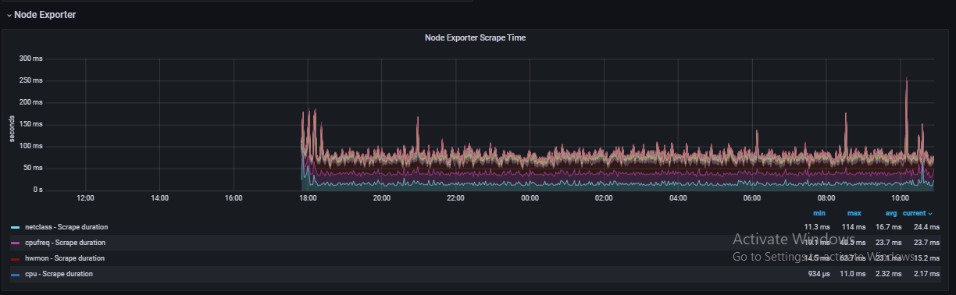

1. **DCGM Exporter Dashboard**

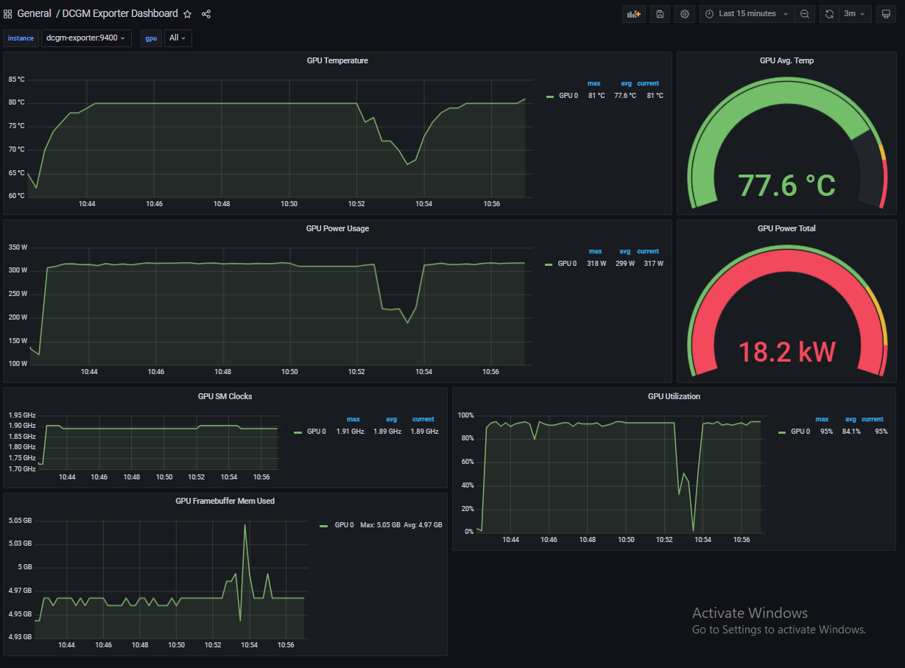

**Note:-** 1. To change the Time range , change it from topbar of the dashboard



2. To change the refresh time go to the dashboard setting then in Auto Refresh give time which dashboard you want to refresh at and then set that time in topbar.

**Filter logs in Grafana**

Step 1: Go to panel of Grafana logs. For ex. I taking Threat monitor process api Dashboard.

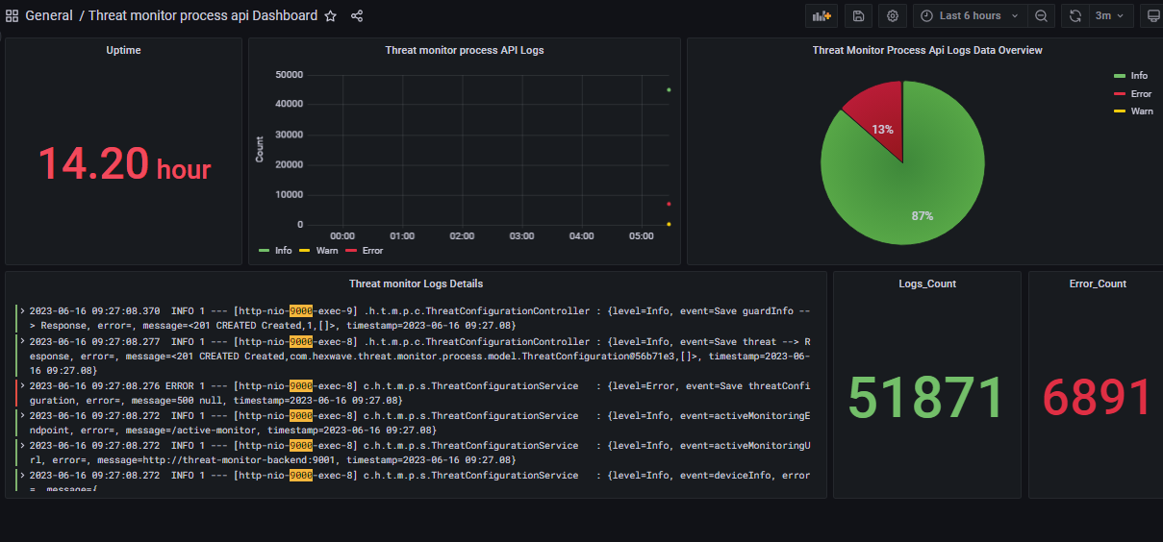

Step 2: Click on Logs Details panel & then click on edit -

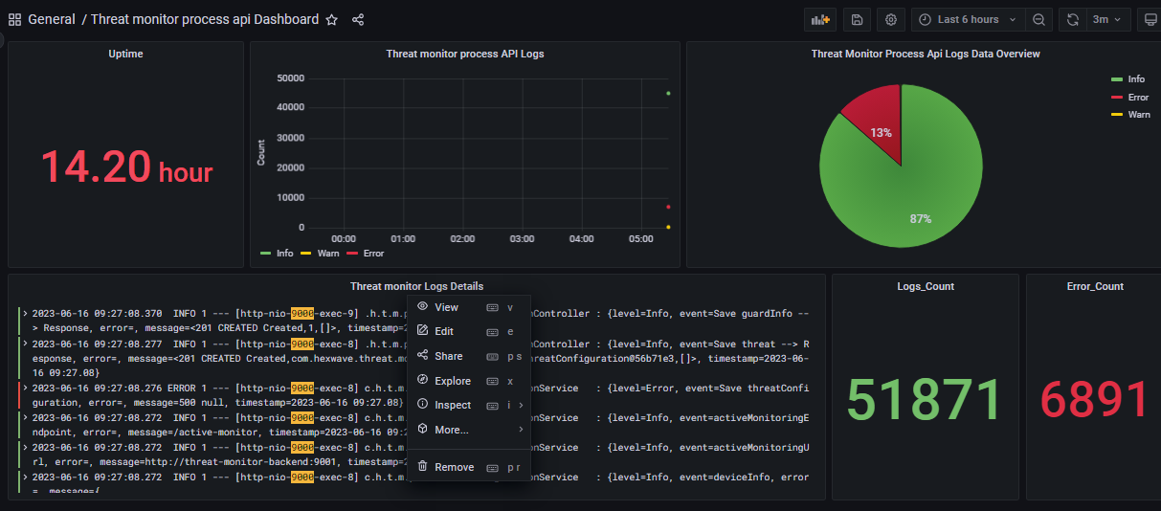

Step 3: On bottom, enter String that you want to search in “Line contains” column & click on Run queries: -

Note: - As I search “objectDetected” then it will show JSON in these logs.

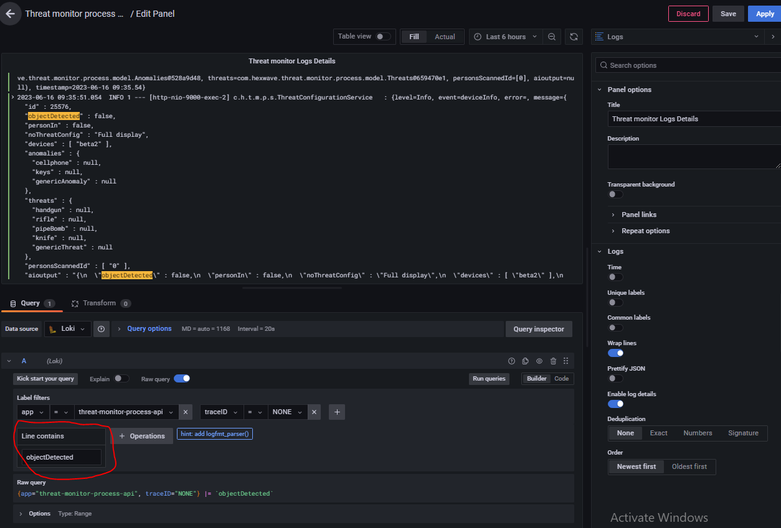

Step 4: In this I search “ERROR” then it will show all error logs by clicking on run queries.

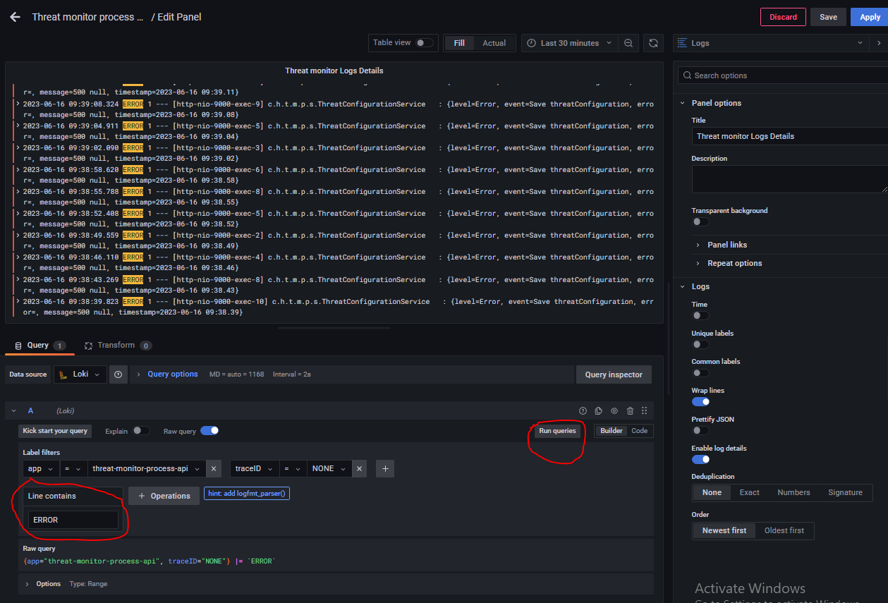

**To Set Grafana Home Page**

Following are the steps to set dashboards list as home page in Grafana: -

1. First mark all the dashboards of Grafana as star. Like: -

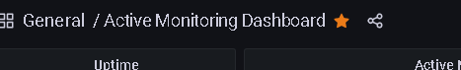

1. Then go to the Configuration from sidebar.

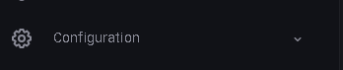

1. Then select Preferences.

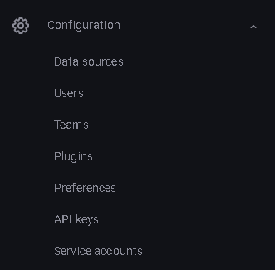

1. Then go to the Home Dashboard option.

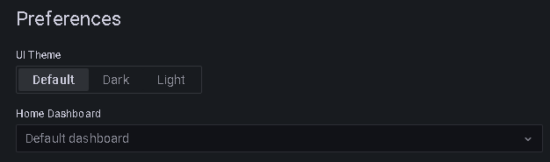

1. Select the dashboard named General/Home. 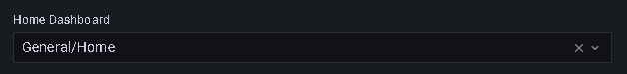
2. Then save it and it will update the home page of Grafana.

Note: - Check it by logout and login again.

**Download logs from Grafana**

There is some time when we want to download our logs of specified time period so, in grafana we can download logs of our particular service if needed. The logs will download in .txt & .csv format and has same line format as it is showing in grafana.

Here are some steps that how we can download our service logs in grafana: -

**Steps-**

1. Go to the URL where grafana is running on port 3000.

e.g. https://localhost:3000

1. Login to your grafana.
2. Go the dashboards, here list of all service dashboards will appear.
3. Select any service dashboard you want to see and download logs here you will see there is dropdown with every panel of dashboard.
4. Then click on that dropdown button you will see a list.

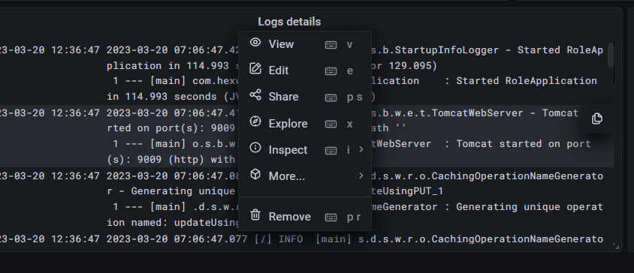

**Fig-1: Drop down with panel**

1. Here various options are given related to panel -

**View-** for viewing panel in large size.

**Edit-**  to edit the panel.

**Share-** to share this panel of dashboard. **Explore-** to view these logs in explore.

**Inspect-** to inspect data coming in panel or to inspect the query running in this panel or to inspect the json model of the panel.

**More-** it has other options to copy a panel or to have duplicate panel. **Remove –** to remove this panel from dashboard.

1. Now go to that explore option then you will be at new page where you can see you overall query and can check other labels also and can apply filters to download logs.

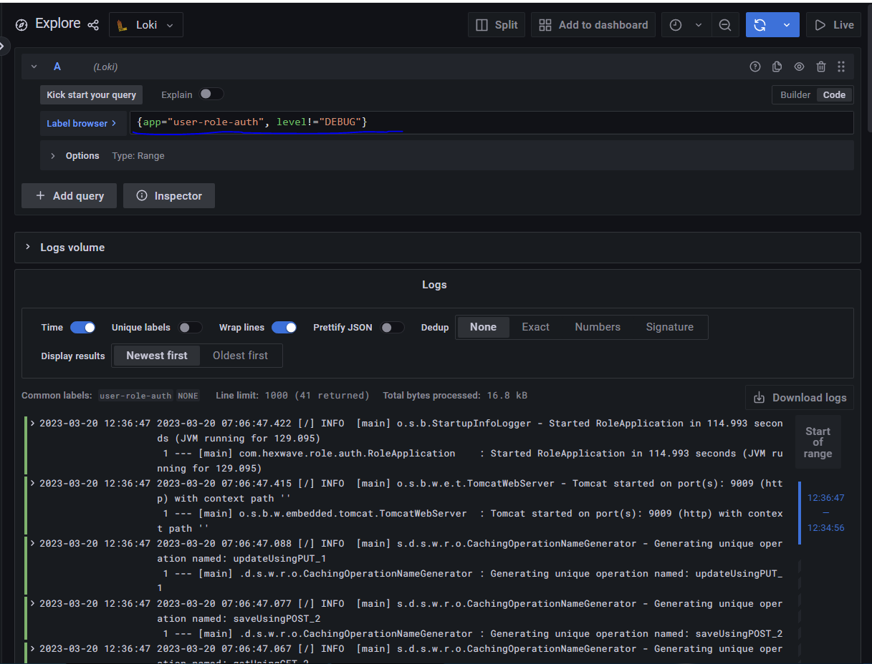

**Fig-2: Logs in Explore Page**

1. Now click on the Download Logs button in the middle at right side all logs will download in a .txt file.

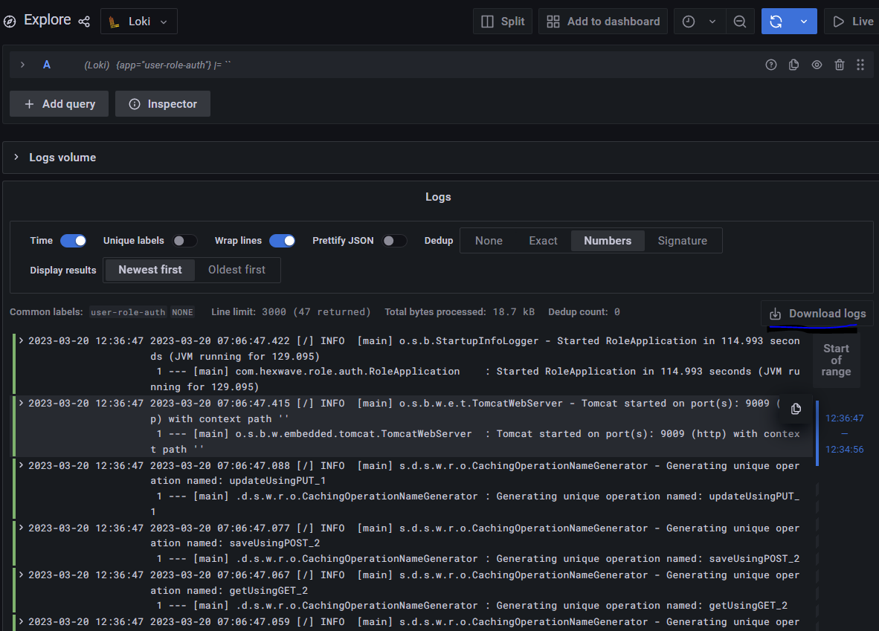

**Fig-3: Download Logs**

1. There is a default line limit of 1000 lines for logs in loki data source you can change it by adding ‘maxLines:’ in the datasource file of grafana.

jsonData:

maxLines: 2000

1. The downloaded file also has logs up to 1000 or up to configured lines in loki datasource.
2. The downloaded file name is as Explore-logs with timestamp.

e.g. Explore-logs-2023-03-20 14_05_24.txt

**Another way to download logs is:**

1. Go to that inspect option in drop down of a panel.
2. Then click on Data option.
3. Then you have option for download logs and for download logs in csv file.

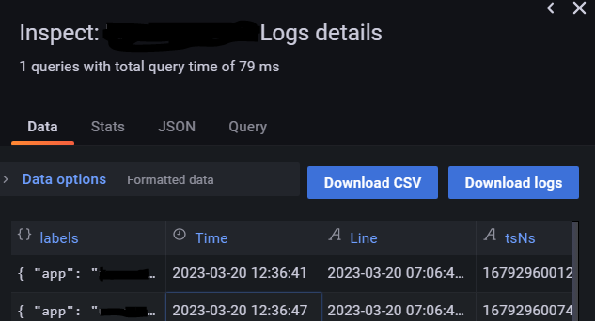

**Fig-4: Download Logs Through Inspect option**

1. The downloaded file name is as panel name with timestamp.

e.g. Logs details-logs-2023-03-20 13_34_26.txt

Or

Logs details-data-2023-03-20 13_35_38.csv